I am a cylinder,
I have a circle on my base,
A circle on my top,
And one curved face!

I am a cube with faces all the same,
I am a dice for your game!
8 vertices here and there,
Square faces everywhere!

I am a cuboid I look like a brick
I am like a cube but extra thick
My faces are rectangle and some could be square
8 sharp vertices here and there
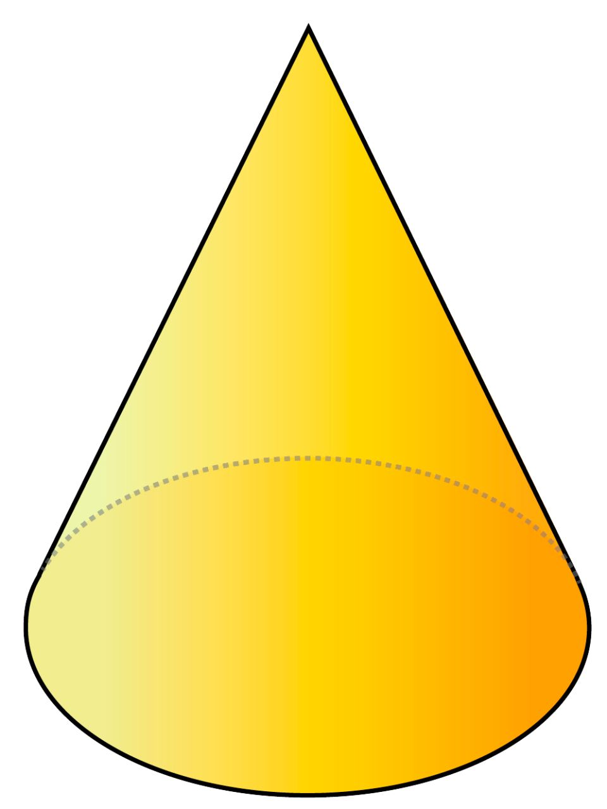

Cone, cone what’s your clue?
It’s a party hat for me and you.
With a face that’s round and a curved face too.
My one vertex is the biggest clue!

