What we are learning…
Reading: The Explorer by Katherine Rundell 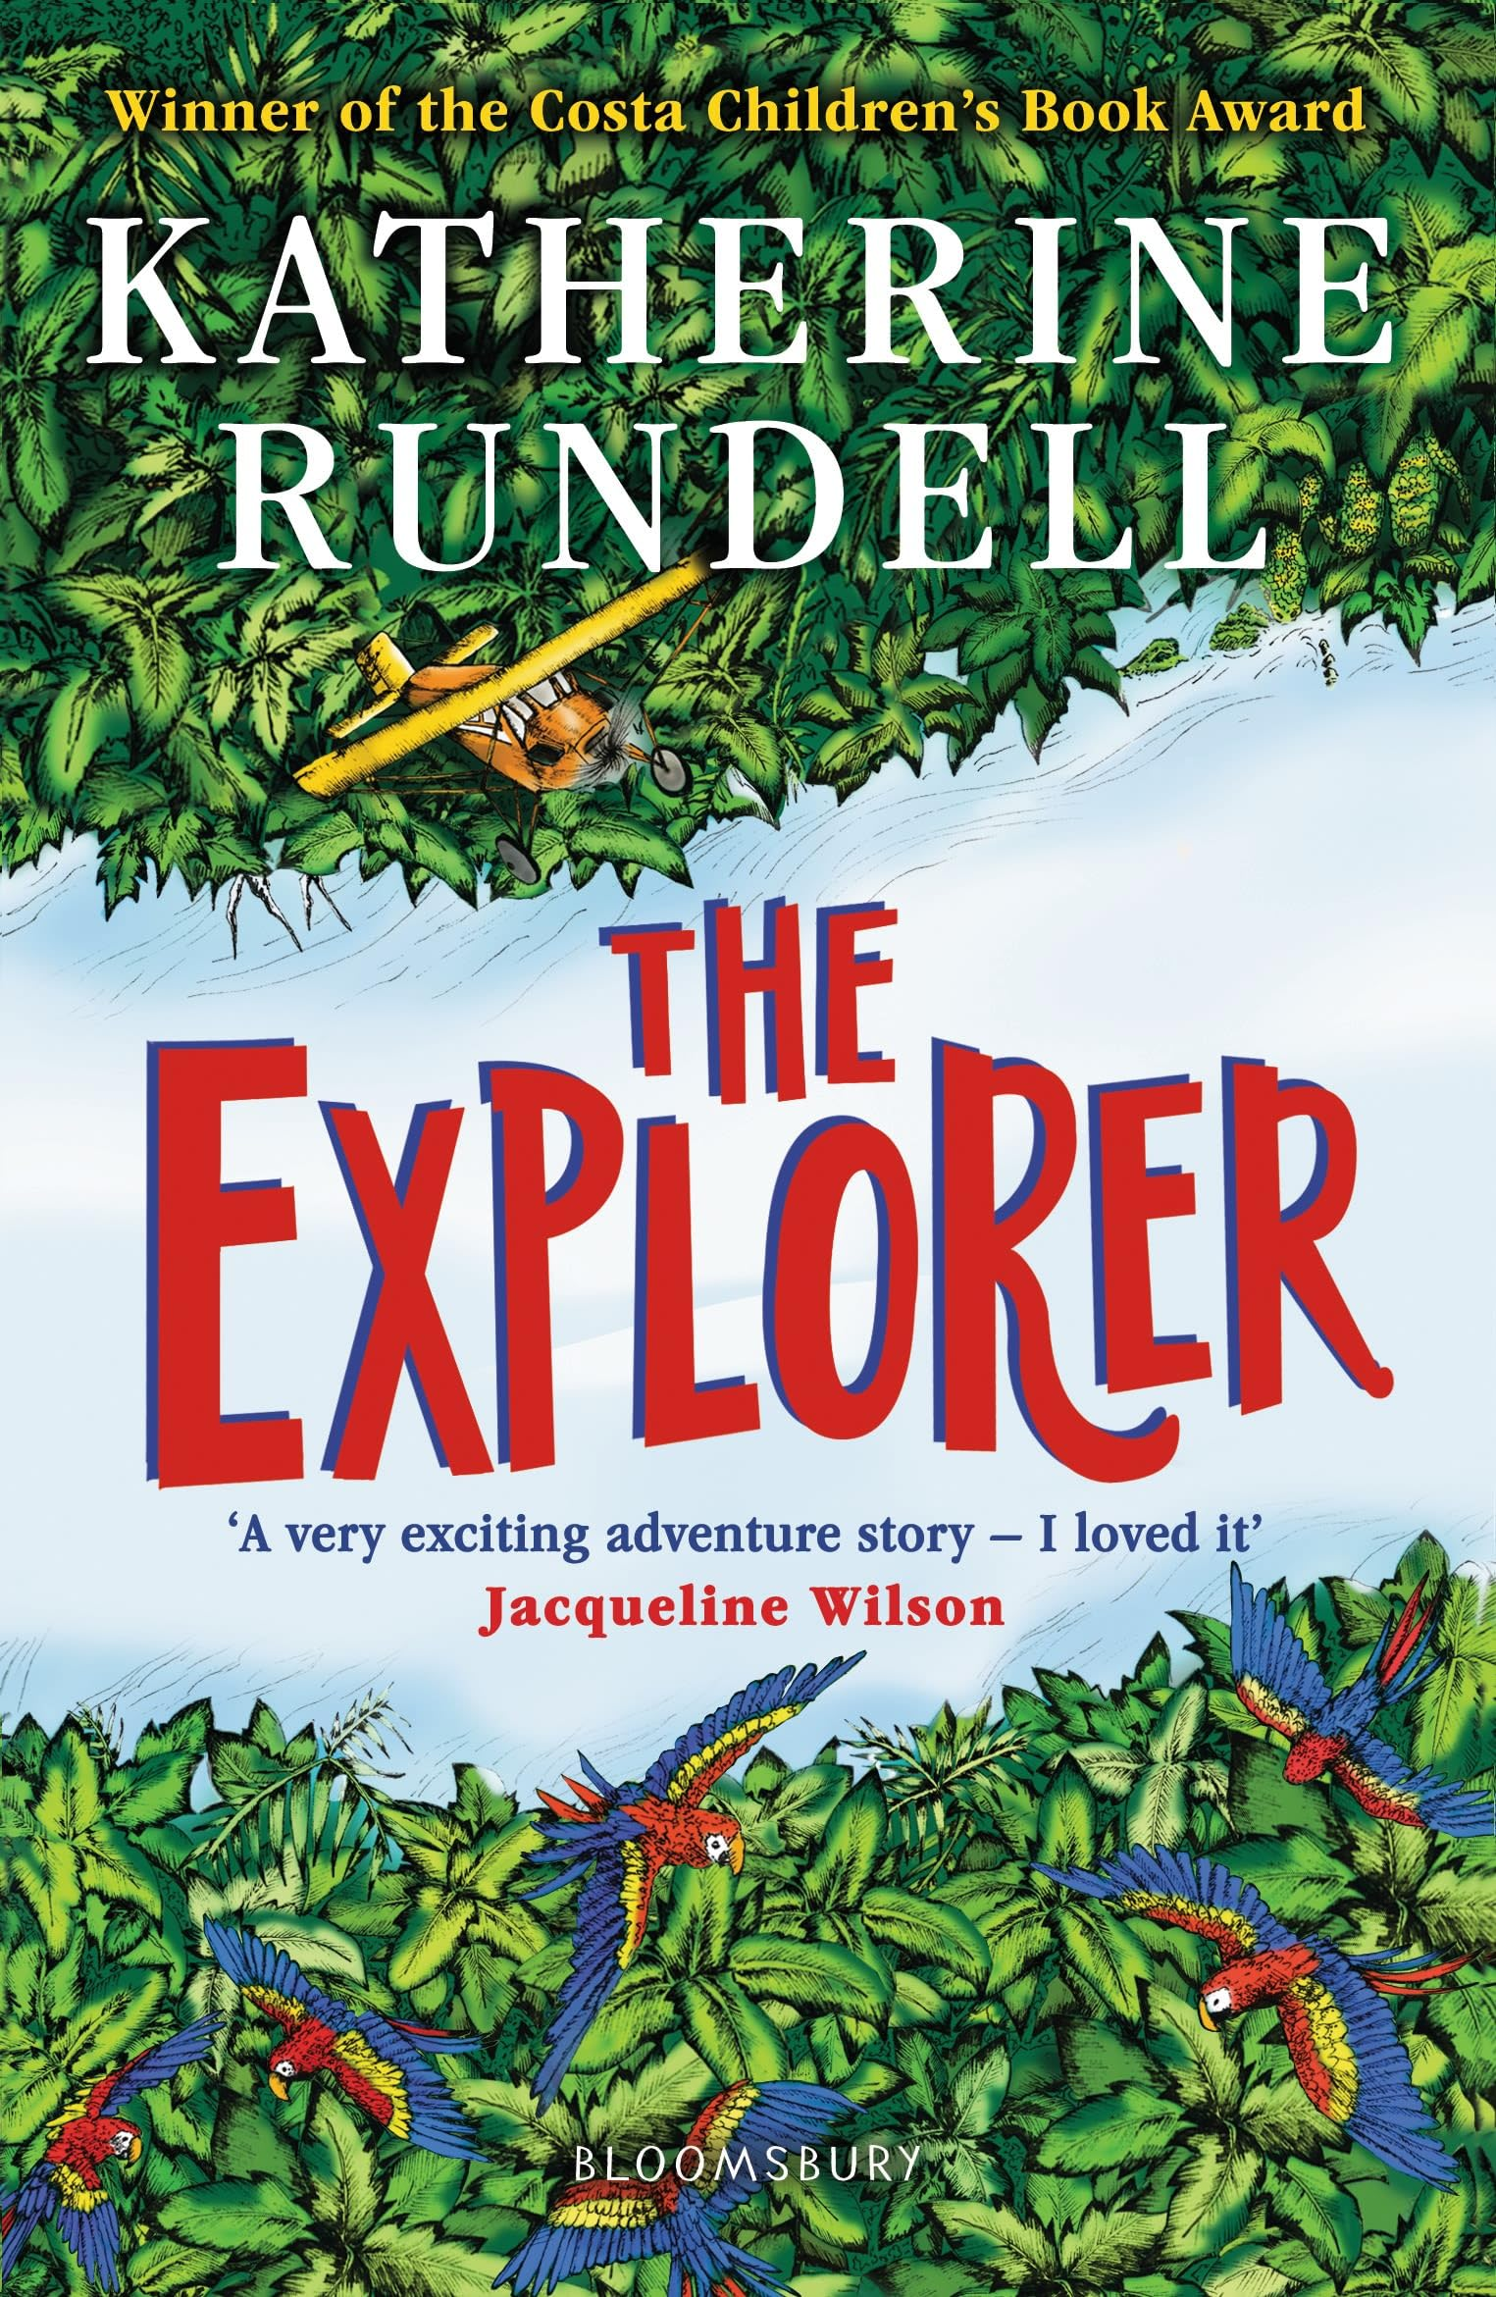

Writing: Narrative based on the Explorer, persuasive text about the rainforest.
Maths: Time, Measure, shape, statistics
Science: Sound
P.E:
History: How did the Achievements of the Ancient Maya impact their society and beyond?
DT - Textiles
Music: Soul/ gospel music

French: Les Habitats continued
Computing: Effective searching, making music
R.E: Islam: How does Ibadah (worship) show what is important to Muslims?
PSHE: Money, families and friendships, respecting others

How can you help?

Reading – encourage reading a variety of texts for example, Journey to the River Sea, The girl who rode an elephant
Visit the library – look for books linked to the Mayans, parts of the body, the rainforest, Islam
Times table Practice – quick recall
Encourage use of websites – maths.co.uk, spag.com, spelling shed.
History – Have discussions at home about the Mayans and their similarities and differences to other cultures and historical periods
Useful websites –
https://www.purplemash.com

Trips / extra activities
Morden Mosque 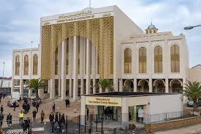

Year 3 and 4
Summer 2

The Mayans

Key Vocabulary
Week 1 - Civilization, Worship
Week 2 – Ceremony, ritual
Week 3 – sacred, belong
Week 4 – Pitch, volume
Week 5 – source, reflect
Week 6 – prophet, sacrifice
Week 7 - Echo, vibration

Vibrate

Vision and values
“All things are possible for one who believes”
Respect – understanding different cultures and respective differences.

