What we are learning…  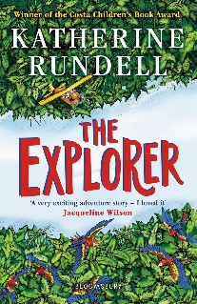  Reading: The Explorer by Katherine Rundell  Writing: Non-Chronological Report based on animals of the Amazon Rainforest and a persuasive text on deforestation.  Maths: Fractions, Money and Time  R.E: Islam: How does Ibadah (worship) show what is important to Muslims?  Science: Living Things and Their Habitats  Geography: Why are rainforests important to us?  P.E: Rounders and Athletics  Art: Working in three dimensions – the art of display or sculpture.  Music: Lean On Me - Soul/Gospel  French: Les Habitats  Computing: Branching Databases and Simulations  PSHE: Making friends; feeling lonely and getting help. Managing secrets; resisting pressure and getting help; recognising hurtful behaviour. | Trips and extra activities  On 24th April 2025, we will be taking part in a Samba Workshop, linked with our South American / Brazil topic and with our music lessons. | How can you help?  Reading: Set aside a special time to read, read a range of different genres, get caught reading yourself and show that reading is not just for children, read to each other, set a challenge, use audiobooks, visit the library or use your child’s favourite films or games as a springboard into reading.  Maths: Incorporate mathematics into everyday routines and activities; telling the time, using money and coins or counting and comparing quantities, use maths talk every day, ask your child to teach you new strategies and solve problems taught in class, play maths games together, practice times tables and maths games online. Explore websites such as Times table rock stars, Sumdog, Hit the Button NRICH (http:// nrich.maths.org/) or Transum (http://www.transum.org/)  Day visits/Experiences: visit the library, visit relevant museums,  Useful websites –  BBC Bitesize: https://www.bbc.co.uk/bitesize/levels/zbr9wmn  Purple Mash: https://www.purplemash.com
Year 3
Summer Term 1

Why are rainforests important to us?
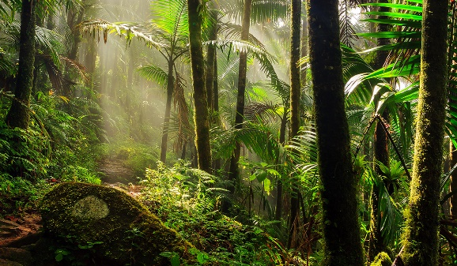
 | Vision and values  “All things are possible for one who believes” | Key Vocabulary  Week 1: vegetation and deforestation  Week 2: habitat and classify  Week 3: invertebrate and vertebrate  Week 4: mosque and Qu’ran  Week 5: position and construct  Week 6: drought and community

