What we are learning…
Reading: Sir Gawain and the Green Knight by Michael Morpurgo
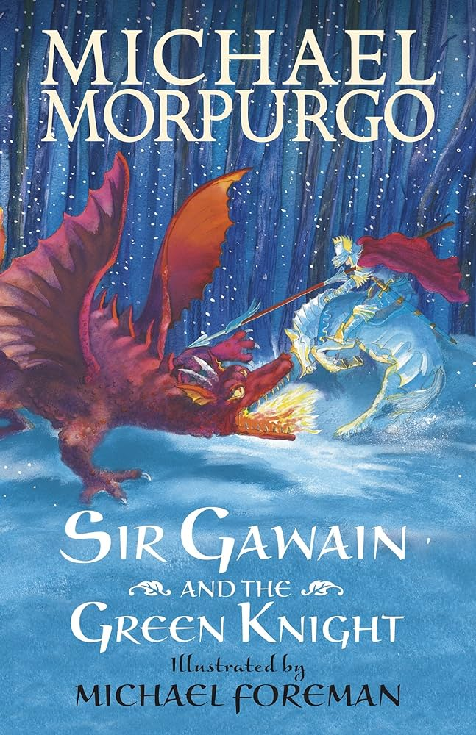
Writing: Animal poetry and a non – chronological report about the Anglo Saxons
Maths: Place Value & Addition and Subtraction
Science: Digestive system
P.E: Ball skills and netball
History: The Anglo Saxons
Art: Story Telling
Music: Playing with rhythm

French: Moi dans le monde
Computing: Coding
R.E: Christianity – What did God promise his people?
PSHE: Similarities and Differences between people

How can you help?

Reading – encourage reading a variety of texts for example, Beowulf by Michael Morpurgo, The Lost Girl King by Catherine Doyle
Visit the library – look for books linked to the Anglo Saxons or King Arthur read other Michael Morpurgo texts
Visit relevant museums – British museum, Battle Abbey, Sutton Hoo
Times table Practice – quick recall
Encourage use of websites – maths.co.uk, spag.com, spelling shed.
History – Have discussions at home about the Anglo Saxons and their effect on Great Britain
Useful websites –
https://www.purplemash.com

Trips / extra activities
Butser Farm
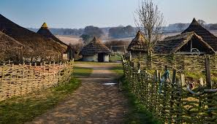

Year 3 and 4
Autumn Term 1
Anglo Saxons
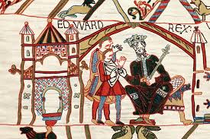

Key Vocabulary
Week 1 – riddle and obscurity
Week 2 – digestion and decay
Week 3 – pulse and plaque
Week 4 – partition and saviour
Week 5 – blessing and settlement
Week 6 – conqueror and invader
Week 7- quest and eternal

Vision and values
“All things are possible for one who believes”
Commitment & love- learning about the changes to Britain people made during the Anglo Saxon times.

