Year 4 Curriculum Map 2026-27
 | Autumn 1 | Autumn 2 | Spring 1 | Spring 2 | Summer 1 | Summer 2
Maths | Place Value  - Numbers to 1000  - Rounding to 10, 100 and 1000  - Counting in 1000s – Partitioning  - 1, 10, 100, 1000 more or less  - Compare and order 4- digit numbers  - Count in 25s  - Negative Numbers  - Roman Numerals  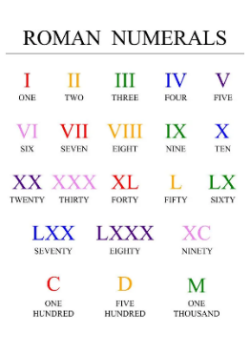  Addition & Subtraction  - Add and subtract 1s, 10s, 100s and 1000s  - Add two 3-digit (crossing and not crossing 10 or 100)  - Add two 4-digit numbers (no exchange then with exchange)  - Subtract a 3-digit number from a 3-digit number no exchange | Addition and Subtraction  - Subtract two 4-digit numbers (no exchange then with exchange)  - Efficient subtraction  - Estimate answers  - Checking strategies  Area  – Counting squares  - Making shapes - Comparing area  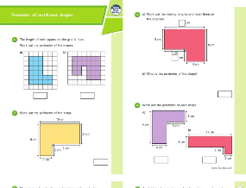  Multiplication and Division  - Multiply and divide by 10 and 100  - Multiply by 1 and 0  - Divide by 1 and itself  - The 3, 6, 7 and 9 times-table | Multiplication and Division  - The 11 and 12 times tables  - Multiply 3 numbers - Factor pairs  - Efficient multiplication - Written methods  - Multiply and Divide 2- digits and 3-digits by 1-digit  Length and Perimeter  - Equivalent lengths  - Add and subtract lengths  - Measure perimeter  - Perimeter of a rectangle  - Perimeter of rectilinear shapes  Fractions  - Unit and non-unit fractions  - Tenths  - Count in tenths  - Equivalent fractions  - Fractions greater than 1  - Counting in fractions  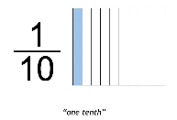 | More Fractions  - Add and subtract fractions - Subtract from whole amounts  - Fractions of a set of objects  - Calculate fractions of a quantity  Decimals  - Tenths and hundredths  - Tenths as decimals  - Divide 1-digit and 2- digits by 10  - Hundredths - Hundredths as decimals  - Divide 1 or 2-digits by 100  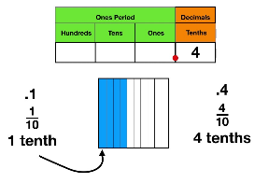 | Decimals  - Make a whole  - Write, order and compare decimals  - Round decimals  - Halves and quarters  Money  - Ordering and estimating money  - Convert pounds to pence  - Adding and subtracting money  - Give change  - Four operations  Time  - Telling the time to the nearest minute - Using a.m. and p.m.  - 24-hour clock  - Hours, minutes, seconds - Years, months, weeks, days  - Analogue to digital 12-and 24-hour  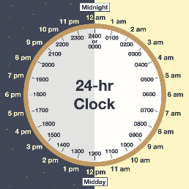 | Shape  - Properties of a shape  - Turns and angles  - Identify and compare angles  - Recognise and describe 2D shapes  - Triangles - Quadrilaterals  - Symmetry  - Horizontal and vertical  - Lines of symmetry  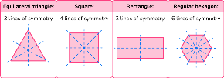  Statistics –  Interpret charts  - Comparison, sum and difference  - Line graphs  Position and direction  - Describe position  - Draw on a grid  - Move on a grid  - Describe movement on a grid
Literacy | Poetry – animal shape poems  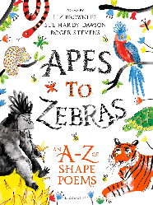  Sir Gawain and The Green Knight  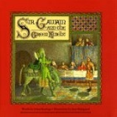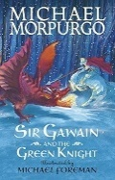  Y3 – Selina Hastings  Y4 – Michael Morpurgo  Unit 1 – Character description  Unit 2 – Letter/diary  Unit 3 – Story  Non-chronological reports  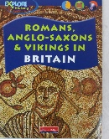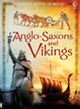  Y3 – Explore history  Y4 – Usborne history of Britain | The Owl who was Afraid of the Dark (Jill Tomlinson)  Y3 – picture book version  Y4 – chapter book version  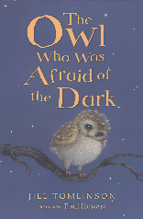  Unit 1 – Setting description dark  Unit 2 – Re-write chapter  Unit 3 – Own story about chosen animal  Rivers  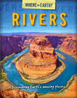  Information text | How to be a Viking Y3  How to Train a Dragon Y4  (Cressida Cowell)  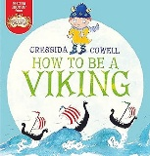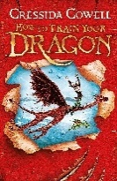  Unit 1 – Dialogue  Unit 2 – New chapter  Unit 3 – Write own adventure with the same characters  Newspaper report – Vikings (Lindisfarne)  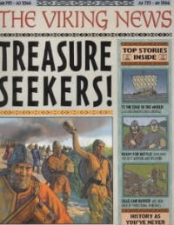 | The Tempest – Y3+4 performance – playscripts  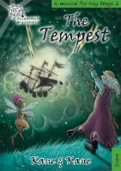  Story versions  Y3 Picture book  Y4 Chapter book  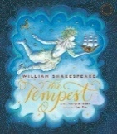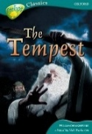  Unit 1 – character descriptions  Unit 2 – Write a new scene  Unit 3 – Story  Instructions – recipes linked to food topic  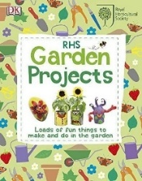 | Into the Jungle Y3  The Explorer Y4  (Katherine Rundell)  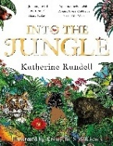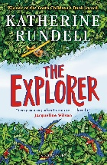  Unit 1 – setting descriptions  Unit 2 – write own chapter  Unit 3 – write a sequel  Persuasive text – RangTan – Greenpeace video  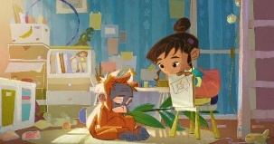  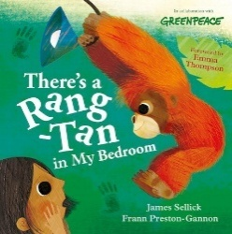 | Non-Chronological Report- animals of the Amazon Rainforest  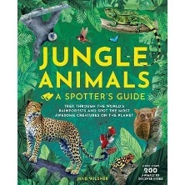  Poetry – narrative poem  Chocolate Cake  (Michael Rosen)  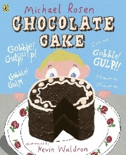
History & Geography | What changed in Britain after the Anglo-Saxon invasion? 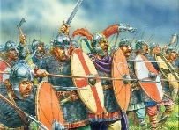  Britain’s settlement by Anglo-Saxons and Scots  Use dates and  historical period terms accurately.  Describe changes within and between periods and societies I have learned about.  Suggest which  people and causes and consequences of change are  more important. | What are rivers and how are they used?  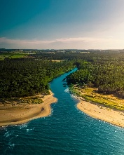  Children learn what rivers are, how they work, and why they’re important in the world around us.  Pupils learn about the journey of a river—from its source to where it ends at the sea—and explore key ideas like erosion, transportation, and deposition. They discover how rivers shape landscapes, support wildlife, and influence where people live.  Children also build practical geography skills by using maps, atlases, diagrams, and digital tools to locate rivers and follow their paths. | Were the Vikings raiders, traders or settlers?  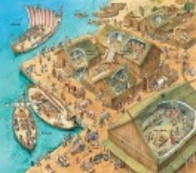  Investigating whether the Vikings were raiders, traders or settlers, making boats to see if the Vikings were engineers and exploring causes and consequences.  Making deductions from sources, identifying the author’s viewpoint and explaining how this impacts the accuracy of the source. | Where does our food come from?  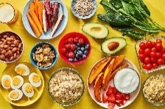  Looking at the distribution of the world’s biomes and mapping food imports from around the world; learning about trading fairly, focusing on Côte d’Ivoire and cocoa beans; exploring where the food for the children’s school dinners comes from and the argument of ‘local versus global’. | Why are rainforests important to us?  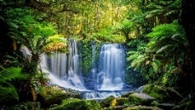  Developing an understanding of biomes, ecosystems and tropics; mapping features of the Amazon rainforest and learning about its layers; investigating how communities in Manaus use the Amazon’s resources; discussing the global human impact on the Amazon; and carrying out fieldwork to compare and contrast two types of forest. | How did the Achievements of the Ancient Maya impact their society and beyond?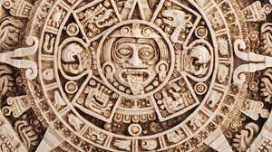  Children explore the achievements of ancient peoples like the Maya by investigating historical and archaeological evidence. Through the observation and analysis of artefacts, children scrutinise their settlement strategies in rainforests, the cultural significance of chocolate and the impact of their beliefs, inventions and decline within and beyond their society.
Art/ DT | Drawing – Story telling through drawing (Laura Carlin, Shaun Tan)  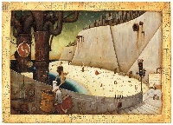  Informed drawing choices — refine drawings, use art vocabulary, explore line/tone/texture.  Idea exploration — observe, question starting points, learn from different artists and cultures.  Storytelling through drawing — use influences and sketchbook research to create imaginative narrative images.  Evaluating & developing work — compare approaches and improve artwork through reflection. | Aspect: Electrical systems  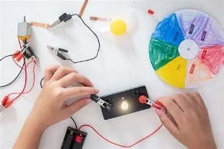  Designing — identify user needs, set design criteria, sketch and model ideas.  Making — plan steps, use tools accurately, build series circuits, add simple programming.  Evaluating — analyse existing products and review their own work against criteria.  Technical knowledge — understand circuits, switches and control; use correct technical vocabulary. | Surface and colour – Exploring pattern or exploring still life  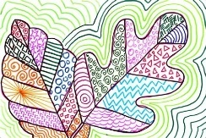  Pattern exploration — match tools to materials and combine skills confidently.  Collage/textiles choices — extend work using collage or textiles.  Refining ideas — refine choices using art vocabulary.  Collecting visual info — gather visual/tactile references.  Paste‑resist experimenting — try simple resist techniques.  Exploring still life  Colour mixing — mix and match colours accurately using tint/tone/shade/hue | Aspect: Mechanical systems  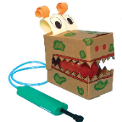  How to Train a Dragon (dragon)  Technical knowledge — understand pneumatic systems and use correct technical vocabulary.  Designing — create ideas and design criteria based on user needs; sketch and model with annotations.  Making — plan steps, use tools accurately, and build pneumatic mechanisms with tubing, syringes and balloons.  Evaluating — analyse and evaluate products. | Working in three dimensions – the art of display or sculpture (link to Brazilian festivals)  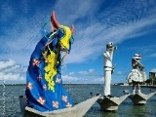  The art of display or sculpture, structure, inventiveness and determination.  Choose suitable 3D techniques and materials.  Shape, space & form — show understanding of structure and form.  Planning & making — plan, design, make and adapt models.  Talking about work — describe work as sculpted, modelled or constructed.  Colour mixing — mix colours accurately using tint/tone/shade/hue | Aspect: Textiles Focus: 2D shape to 3D product Link: Purses (money PSHE)  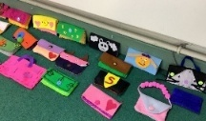  Designing — create ideas and design criteria; sketch, prototype and use pattern pieces.  Making — plan steps, use tools accurately, and choose suitable fabrics and fastenings.  Evaluating — analyse textile products.  Technical knowledge -strengthen and join fabrics securely; understand patterns and seam allowances; use technical vocabulary.
Science | Animals including Humans  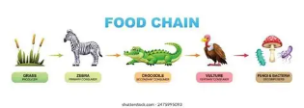  Describe the simple functions of the basic parts of the digestive system in humans.  Identify the different types of teeth in humans and their simple functions.  Construct and interpret a variety of food chains, identifying producers, predators and prey.  Working scientifically  Observe the similarities and differences in human/animal teeth  Interpret and present learning of the digestive system through models  Set up tests to see the effects of different liquids on tooth decay  Make predictions based on knowledge of liquids to decay teeth  Record results in a table and bar graph  Ask questions to find out what animals eat  Evaluate learning | Electricity  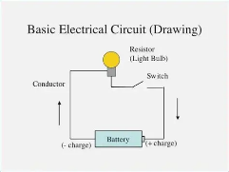  Identify common appliances that run on electricity.  Construct simple series electrical circuit, identifying and naming its basic parts, including cells, wires, bulbs, switches and buzzers.  Identify whether or not a lamp will light in a simple circuit, based on whether or not the lamp is part of a complete loop with a battery.  Recognise that a switch opens and closes a circuit and associate this with whether or not a lamp lights in a simple series circuit.  Recognise some common conductors and insulators, and associate metals with being good conductors.  Working scientifically  Record work using labelled drawings  Make predictions using scientific language  Interpret results using scientific knowledge  Identify properties of different materials  Pose scientific questions  Record and explain how electricity can help people | States of Matter  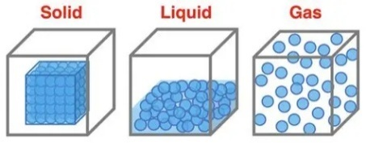  Compare and group materials together, according to whether they are solids, liquids or gases.  Observe that some materials change state when they are heated or cooled, and measure or research the temperature at which this happens in degrees Celsius  Identify the part played by evaporation and condensation in the water cycle and associate the rate of evaporation with temperature.  Working scientifically  Make careful observations and identify similarities and differences  Make predictions using evidence and observations  Use a thermometer to take accurate measurements  Interpret what has been observed using scientific knowledge  Set up tests to answer questions  Record using diagrams |  | Living Things and Habitats  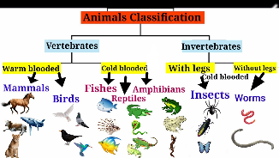  Recognise that living things can be grouped in a variety of ways.  Explore and use classification keys to help group.  Identify and name a variety of living things in the environment.  Recognise that environments can change and this can sometimes pose dangers to living things.  Working scientifically  Observe characteristics of living things  Identify similarities and differences in characteristics  Gather and record data in a table  Record observations from scientific enquiry  Ask relevant questions to classify things  Use evidence to answer questions and present findings  Record findings about endangered species | Sound  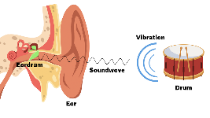  Identify how sounds are made, associating some of them with something vibrating.  Recognise that vibrations from sounds travel through a medium to the ear.  Find patterns between the volume of a sound and the strength of the vibrations that produced it.  Recognise that sounds get fainter as the distance from the sound source increases.  Working scientifically  Observe vibrations which cause sound and measure distance to nearest cm  Set up tests and record results  Record results in a table and spot patters  Record sound heard in a table and produce a line graph  Evaluate musical instruments based on sound and knowledge of pitch  Observe how sounds are created  Set up tests based on questions asked.
Computing  Cycle B  (mixed year) | Animation  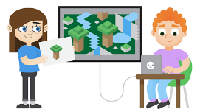  6 lessons  - To understand what animation is.  - To understand the term onion skinning and be able to use this technique for 2D computer animations.  - To know how to enhance simple animations using animation software.  - To plan an animation.  - To create a narrative through animation.  - To evaluate animations. | Logo  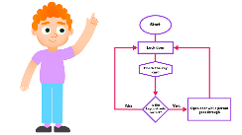  4 lessons  - To know key commands and input simple instructions.  - To use a variety of commands to create shapes using multi-line mode.  - To use the repeat command.  - To change the line thickness and colour.  - To use procedures to write instructions. ​ | Branching databases  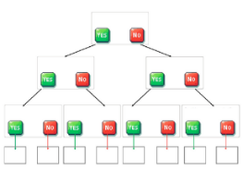  4 lessons  - To understand the concept of using 'Yes' or 'No' questions to sort objects.  - To understand and use a branching database effectively.  - To plan and create a branching database.  - To test and debug branching databases to correct errors. | Sound Stories    4 lessons  - To understand what makes audiobooks effective and identify the key features that make them engaging.  - To plan and write a script for an engaging audiobook.  - To record clear narration and add sound effects to an audiobook.  - To edit, improve and finalise an audiobook using recording and sound design tools. | Coding  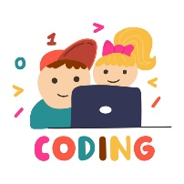  - lessons  - To understand and use repeats, looping code and number variables.  - Designing a program.  - Coding a program.  - Making a playable game. | Touch Typing    4 lessons  - To learn correct finger positioning on the keyboard and understand when to use the left or right hand.  - To learn how to type numbers accurately and to use the shift key for capital letters.  - To practise typing punctuation marks and symbols and build accuracy with simple words.  - To practise typing sentences using capital letters, spaces, and full stops.  Introduction to AI  4 lessons  - To understand what Artificial Intelligence is and some of the tasks it can carry out.  - To learn to communicate effectively with AI tools by writing clear and precise prompts.​  - To learn how to be a good digital citizen when using AI.​  - To think about how AI might develop in the future.
PSHE  Cycle B  (mixed year) | My healthy self: How can I take care of my mind and body?  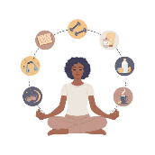  Examining the connection between the mind and body by recognising and describing a wide range of emotions and feelings. | Citizenship: What rights and responsibilities do we have?  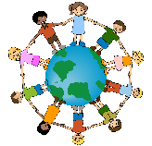  Learning about rights, responsibilities and citizenship by exploring children’s rights, human rights and why they matter. | Health protection: How can we prevent illness and injury and respond if they happen?    Investigating how healthy habits and medicines help prevent illness by exploring hygiene, sun safety, vaccines, basic first aid and how to seek medical help, including calling 999 in an emergency. | My healthy self: How can I make healthy choices?  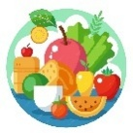  Understanding how healthy choices support both physical and mental wellbeing by exploring exercise, nutrition and hydration. | Citizenship: How can I spend money wisely?    Learning about managing money by examining the different ways people pay for goods and services, including cash and cards. Pupils develop an understanding of budgeting, value for money and financial decision-making, while considering how money can influence people’s feelings and choices | Growing up: How will my body and emotions change as I grow up?  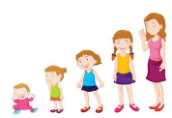  Learning about the physical and emotional changes that occur during puberty, pupils recognise that these changes are normal and happen at different times for everyone.
RE | Christianity:    What did God promise his people?  Pupils learn about the Christian belief that God makes and keeps promises (covenants) with his people, focusing on the stories of Noah, Abraham and Moses. They explore how these covenants reveal God’s faithfulness, love and expectations of his people, and how these beliefs continue to influence Christians today. Pupils investigate key Bible texts, develop their understanding of Christian beliefs and sources of authority, and reflect on the importance of promises, commitment and trust in their own lives, making connections between religious teachings and personal experience. | Humanism:  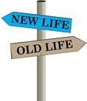  How do non-religious people celebrate new life?  Pupils learn about Humanism as a non-religious worldview and explore why celebrating new life is important to many people. They investigate how Humanists welcome babies through naming ceremonies and consider the values these ceremonies express, including love, belonging, community and the freedom for children to make their own choices about beliefs in the future. Pupils compare religious and non-religious celebrations of new life, examine how ceremonies help shape identity and a sense of belonging, and reflect on the significance of new beginnings and special milestones in their own lives. | Christianity:    What did Jesus say about God’s kingdom? And why is it ‘good news’?  Pupils explore Jesus’ teaching about the Kingdom of God, particularly through parables and stories that show what life is like when people follow God’s ways. They learn that Christians believe the Kingdom of God is ‘good news’ because it brings hope, forgiveness, justice, peace and God’s love for everyone. Pupils examine how Jesus’ teachings challenged people to care for others and live differently, and consider how Christians today try to put these values into practice. | Christianity:  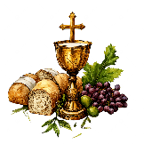  Is communion a celebration or an act of remembrance?  Pupils explore the meaning and significance of Holy Communion (the Eucharist) in Christian worship. They learn about the Last Supper, its links to the Jewish festival of Passover, and how bread and wine are used as symbols of Jesus’ body and blood. Pupils investigate why many Christians see Communion both as an act of remembrance of Jesus’ death and sacrifice and as a celebration of salvation, unity and God’s love. They consider how the practice helps Christians feel connected to God and one another, and reflect on the importance of remembering significant events and celebrating belonging within communities. | Thematic:  Are words more important than actions?  Pupils explore whether words or actions are more important, examining key teachings, beliefs and values from Christianity, Judaism, Islam and Humanism. They learn that many religious and non-religious worldviews express their core beliefs through important statements, prayers or creeds, and investigate how these beliefs influence the ways individuals and communities behave. Pupils consider the relationship between belief and action, evaluating how values such as compassion, justice and respect are put into practice, and reflect on whether actions speak louder than words. | Islam:    How does Ibadah (worship) show what is important to Muslims?  pupils explore the meaning of ibadah (worship) in Islam and how it reveals what is most important to Muslims. They learn about key Islamic beliefs, including Tawhid (the oneness of Allah), the importance of the Qur’an as guidance from God, and the role of salah (prayer) and the mosque in Muslim life. Pupils investigate how acts of worship express devotion, obedience, equality and belonging within the Ummah (the worldwide Muslim community), and consider why worship is an important part of many people’s lives.
PE | Netball   - To develop passing, catching and footwork skills.  - To understand the rules and positions within netball.  - To apply attacking and defending principles in conditioned games.  - To improve teamwork and communication skills.  Swimming  - To develop confidence and competence in the water.  - To improve technique in a range of swimming strokes.  - To understand and apply water safety principles.  - To develop stamina and efficiency when swimming over distance.  - To evaluate and improve individual swimming performance. | Football   - To develop dribbling, passing and receiving skills with control.  - To understand and apply attacking and defending principles.  - To improve decision-making during small-sided games.  - To evaluate and improve individual and team performance.  Ball skills   - To develop throwing, catching, bouncing and striking skills with increasing control.  - To improve hand-eye coordination and movement when handling a range of balls and equipment.  - To apply sending and receiving skills in individual, paired and small-group activities.  - To evaluate and improve performance whilst working cooperatively with others. | Tag rugby  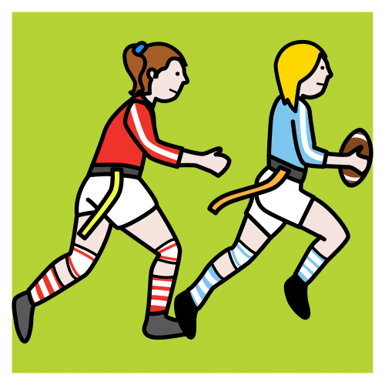  - To develop passing, catching and evasion skills.  - To understand the principles of attack and defence.  - To apply tagging rules within competitive game situations.  - To develop teamwork, communication and tactical awareness.  Dance   - To develop movement patterns and expressive skills.  - To perform actions with control, coordination and rhythm.  - To create and develop short dance sequences.  - To work collaboratively to compose and refine performances.  - To evaluate and improve dance performances. | Hockey   - To develop dribbling, passing and receiving skills using a hockey stick.  - To understand and apply attacking and defending strategies.  - To improve control and accuracy when moving with the ball.  - To evaluate and improve performance during play.  Gymnastics  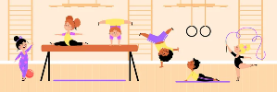  - To develop balance, strength, flexibility and coordination.  - To perform a range of gymnastic actions and shapes safely.  - To link movements to create simple sequences.  - To demonstrate control, precision and technique in performances.  - To evaluate and improve gymnastic sequences. | Rounders 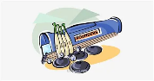  - To develop striking, fielding and catching skills.  - To understand the rules and tactics of rounders.  - To apply attacking and defending strategies during games.  - To work effectively as part of a team.  Athletics    - To develop running, jumping and throwing techniques.  - To improve speed, agility, balance and coordination.  - To understand how to apply effort and pacing in different events.  - To develop personal performance and competitive skills.  - To evaluate and improve athletic performance. | Tennis   - To develop forehand, backhand and rallying skills.  - To improve control, accuracy and consistency when striking a ball.  - To understand and apply simple tactics in competitive situations.  Cricket  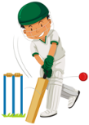  - To develop batting, bowling and fielding skills.  - To understand the basic rules and tactics of cricket.  - To apply attacking and defending principles during games.  - To develop teamwork, communication and decision-making skills.  - To evaluate and improve individual and team performance.
Music | Let Your Spirit Fly  R&B    - To develop an understanding of R&B music and recognise its key musical features.  - Listen to, discuss and compare a range of musical styles  - Identify and respond to the pulse, rhythm, pitch, tempo, dynamics and texture of music.  - Learn and perform the song “Let Your Spirit Fly” with confidence and accuracy; singing as part of a group and singing in two parts  - Play instrumental parts on classroom instruments using notes including C, D and E.  - Compose simple melodies and rhythms  - Build understanding of key musical vocabulary such as structure, verse, chorus, melody, improvise and compose  - Perform, share and evaluate musical work,  - Express opinions about different pieces of music |  | Glockenspiel Stage 1  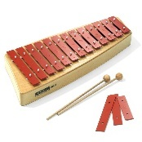  Exploring & developing playing skills  - Develop confidence in playing the glockenspiel  - Learn to read and play the notes C,D, E and F using simple musical notation and perform a range of short melodies  - Recognise how music is organised using bars, bar lines and time signatures  - Understand and perform different note values and rests  - Explore how pitch changes  - Improvise short musical phrases  - Compose simple melodies using the notes C,D, E and F  - Develop understanding of key musical vocabulary including dynamics, texture, structure, melody and notation  - Perform musical pieces independently and as part of a group  - Evaluate and reflect on performances, discussing musical choices and areas for improvement. |  | - Three Little Birds  - Reggae  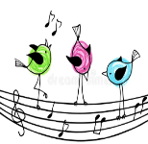  - Develop an understanding of Reggae music and recognise its key musical characteristics  - Listen to and appraise Three Little Birds by Bob Marley and compare it with other reggae songs  - Identify musical elements including pulse, rhythm, pitch, tempo, dynamics and texture  - Recognise the structure of a song,  - Learn to sing Three Little Birds as a class. Singing in unison with vocal control, expression and confidence.  - Play simple instrumental parts using notes such as C, D and E.  - Compose simple melodies and rhythmic patterns using selected notes  - Reflect on performances and evaluate how music creates mood, particularly themes of happiness and positivity found in reggae music
French | Getting to know you  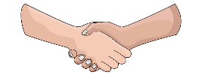  Pupils learn to take their first steps in speaking French by practising simple everyday conversations. They explore key phrases for greetings, introducing themselves, sharing how they feel, and talking about their age, alongside learning numbers from 0–10. Through songs, games and paired activities, children build confidence in listening and speaking, developing accurate pronunciation and the ability to hold a short introductory conversation in French. |  | Family and Friends    Children learn to talk about the people in their lives using simple French vocabulary. They practise naming family members and begin describing friends and classmates using basic adjectives. Pupils build confidence by asking and answering questions about who is in their family, who their friends are, and how to describe them. |  | Holidays and Hobbies    Children learn to talk about the activities they enjoy and the places they might visit on holiday using simple French vocabulary. They practise naming hobbies such as sports, pastimes and leisure activities, and explore holiday words linked to travel and destinations. Pupils build confidence by asking and answering questions about what they like doing, where they go, and how they spend their free time.
Trips & Visitors | History - Anglo-Saxon workshop in school | Geography – visitors from different countries in the UK  Geography – Visit in the local area for geography fieldwork | Art – Tate Britain (Art gallery) | Geography – Food + fair trade workshop | Music - Samba drumming | R.E. - Mosque
Opportunities for outdoor learning and maximising locality | Drawing – use of outdoor classroom for sketching | Local area fieldwork | States of matter temperature study | Visit to local supermarket to look at where food comes from | Local area habitats  Carnival! | Sound experiments

