Year 3 + 4 – Reading Spine
Term | Autumn 1 | Autumn 2 | Spring 1 | Spring 2 | Summer 1 | Summer 2
Geog/  History | Anglo Saxons | UK | Vikings | Food + Fairtrade | Rainforests | Mayans
Literacy | Poetry – animal shape poems  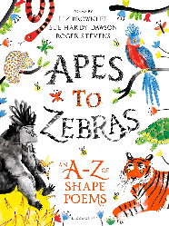  Sir Gawain and The Green Knight  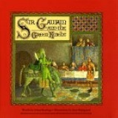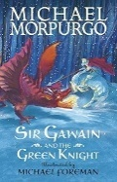  Y3 – Selina Hastings  Y4 – Michael Morpurgo  Unit 1 – Character description  Unit 2 – Letter/diary  Unit 3 – Story  Non-chronological reports  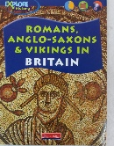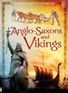  Y3 – Explore history  Y4 – Usborne history of Britain | The Owl who was Afraid of the Dark (Jill Tomlinson)  Y3 – picture book version  Y4 – chapter book version  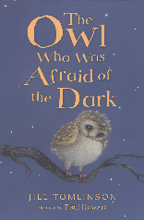  Unit 1 – Setting description dark  Unit 2 – Re-write chapter  Unit 3 – Own story about chosen animal  Rivers  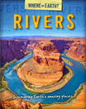  Information text | How to be a Viking Y3  How to Train a Dragon Y4  (Cressida Cowell)  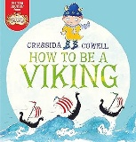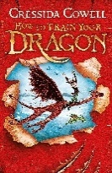  Unit 1 – Dialogue  Unit 2 – New chapter  Unit 3 – Write own adventure with the same characters  Newspaper report – Vikings (Lindisfarne)  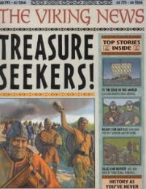 | The Tempest – Y3+4 performance – playscripts  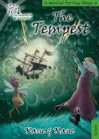  Story versions  Y3 Picture book  Y4 Chapter book  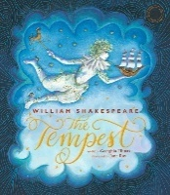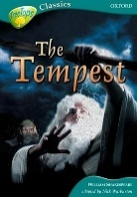  Unit 1 – character descriptions  Unit 2 – Write a new scene  Unit 3 – Story  Instructions – recipes linked to food topic  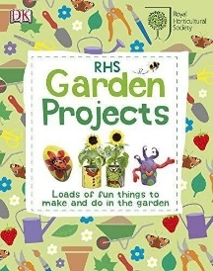 | Into the Jungle Y3  The Explorer Y4  (Katherine Rundell)  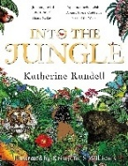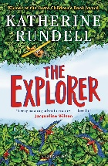  Unit 1 – setting descriptions  Unit 2 – write own chapter  Unit 3 – write a sequel  Persuasive text – RangTan – Greenpeace video  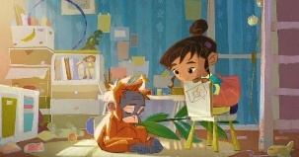  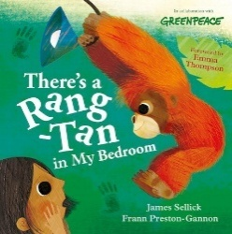 | Non-Chronological Report- animals of the Amazon Rainforest  Y3 Y4  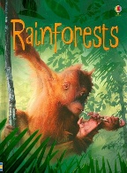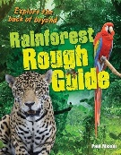  Poetry – narrative poem  Chocolate Cake  (Michael Rosen)  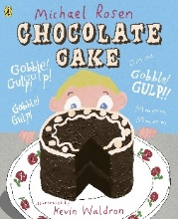
Story time texts
Key authors | Jill Tomlinson  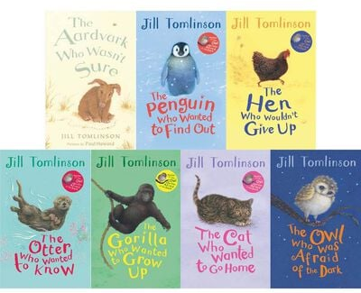 |  | Cressida Cowell  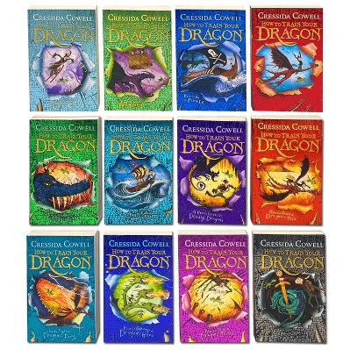 |  | Michael Rosen (poetry focus)  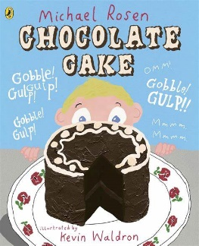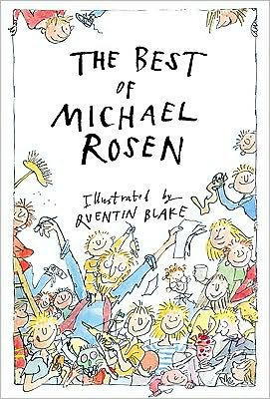
Fiction | 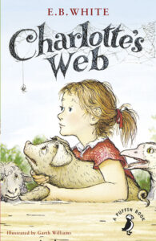  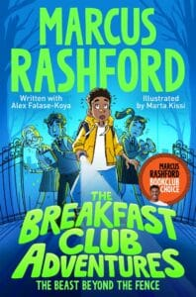  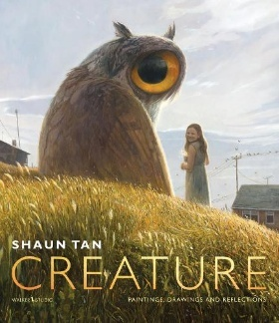 ART | 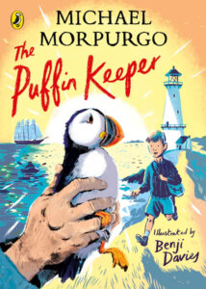  Link to author for Sir Gawain  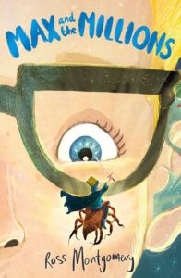  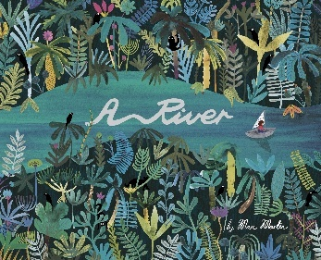 | 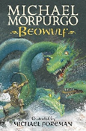 HISTORY  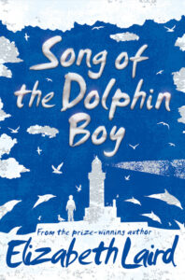  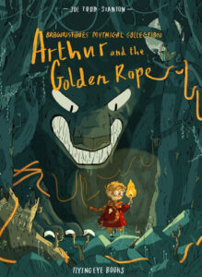 HISTORY  *Graphic novel | 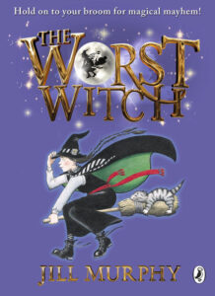  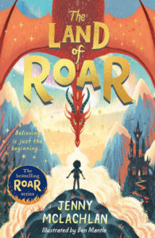  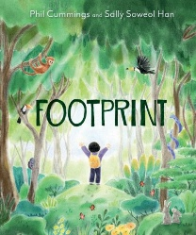  GEOGRAPHY/PSHE | 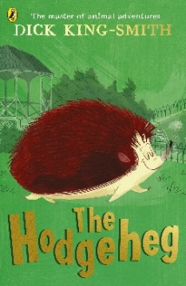  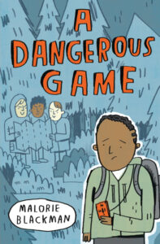 PSHE  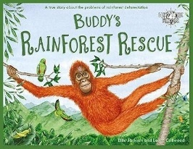  GEOGRAPHY/PSHE | 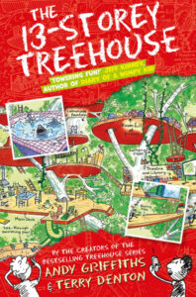  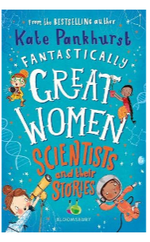SCIENCE  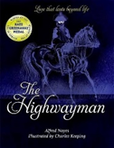  *Poetry
Non-fiction | 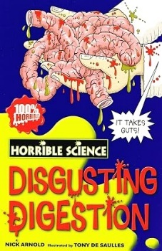 SCIENCE | 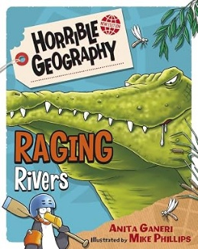  GEOGRAPHY | 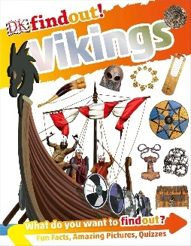  HISTORY | 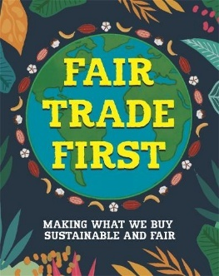  GEOGRAPHY / PSHE | 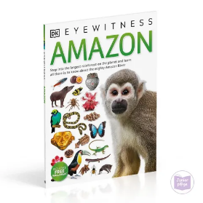  GEOGRAPHY/  SCIENCE | 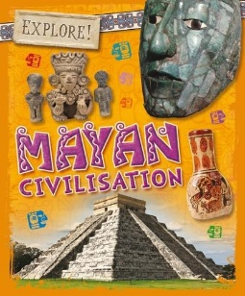  HISTORY

