KS1 Curriculum Map Cycle B

 | Autumn 1  What is it like here? |  | Autumn 2  How am I making history? |  |  | Spring 1  What is the weather like in the UK? |  |  | Spring 2  How have toys changed?  Wb 22.2.27 |  |  | Summer 1  What is it like to live in Shanghai? |  |  | Summer 2  How have explorers changed the world?
Year 1 Maths | Place Value  (within 10)  - Counting 1:1 correspondence - Representing 10  - Counting on and back  - Finding one more/one less  - Greater than less than  - Ordering/ comparing  - Ordinal numbers  - Number lines/tracks  Addition and subtraction  - Part whole model  - Symbols (+, -, =)  - Number bonds to 10  - Fact families  - Simple addition |  | Addition and Subtraction cont.  - Simple subtraction  - Finding the difference  - Comparing addition and subtraction statements  Geometry  - Recognise 3D shapes  - Sort 3D shapes - Recognise 2D shapes  - Sort 2D shapes  - Identifying patterns within 2D & 3D shapes |  |  | Place Value cont. – (Numbers from 11-20)  - Tens and Ones  - One more one less  - Compare objects/  numbers  - Order numbers  Addition and Subtraction (within 20)  - Add by counting on  - Add ones using number bonds  - Find and make number bonds  - Subtraction not crossing 10  - Subtraction, counting back  - Subtraction crossing 10  - Comparing number sentences |  |  | Place value  (within 50)  - Counting to 50 in 10s  - Counting on and back to 50  - Tens and Ones  - Representing numbers to 50  - One more one less  - Compare objects/ numbers  - Order numbers  - Counting in 2s  - Counting in 5s  Length & Height  - Compare lengths  - Compare heights  Mass & Volume  - Introduce weight & mass  - Measure mass  - Compare mass  - Weight & mass problems  - Capacity & volume  - Measure & compare |  |  | Multiplication & Division  - Recap count in 2s  - Recap count in 5s - Count in 10s  - Make equal groups  - Add equal groups  - Intro & make arrays  - Make doubles  - Making equal groups and sharing groups  Fractions  - Making half  - Making a whole  - Finding half of a quantity  - Finding a quarter of a quantity  Position & Direction  - Describe turns  - Describe positions |  |  | Place value (within 100)  - Counting to 100 by making 10s  - Counting on & back  - Introducing the 100 square  - Partitioning numbers  - Comparing/ordering numbers  - One more one less  Money  - Recognising coins  - Recognising notes - Counting coins  Time  - Before & after  - Dates  - Time to the hour  - Time to the half hour  - Writing time  - Comparing time
Maths  Year 2 | Place Value  - Count objects to 100 and read and write  numbers in numerals and words  - Represent numbers to 100 - Tens and ones with part-whole model  - Place value chart  - Compare and order objects and number  - Count in 2s, 5s, 10s, 3s  Addition and Subtraction  - Fact families, bonds to 20  - Check calculations  - Compare number sentences  - Bonds to 100 |  | Addition and subtraction  (within 100)  - Add and subtract 1s  - 10 more and 10 less  Add and subtract 10s  - Add a 2 digit and 1 digit number crossing ten  - Subtract a 1 digit from a 2 digit number crossing ten  - Add two 2 digit numbers not crossing ten then crossing ten  - Subtract 2 digit number from 2 digit number not crossing ten then crossing ten  - Add three 1 digit numbers  Shape  - Count sides and vertices on 2d  - Draw 2d shapes  - Lines of symmetry  - Sort 2d Shapes and make patterns  - Count sides, faces and edges on 3d  - Sort 3d shapes and make patterns |  |  | Money  - Count money  - pence and pound, notes and coins  - Make the same amount  - Compare money  - Find the total/difference/change - Two step problems  Multiplication and division  - Make and add equal groups  - Make arrays  - Multiplication using x symbol and pictures  - Use arrays  - 2s, 5s, 10s times-table - Grouping  - Divide by 2, 5, 10  - Odd and even numbers |  |  | Fractions  -Equal parts  Measure length m  - Compare lengths  - Order lengths  - Four operations with length  - Problems solving  Time  -O’clock and half past  - Quarter past and quarter to  - Telling time to 5 minutes  - Hours and days - Duration of time  - Compare duration of time  Statistics  -Make Tally charts  - Draw pictograms  Interpret pictograms  - Block diagrams |  |  | Position and direction  -Describe position  - Problem solve with position  - Describe movement and turns  - Make patterns with shapes  SATs revision |  |  | Measurement  -Measure length cm  Measure length m  - Compare lengths  - Order lengths  - Four operations with length  - Problems solving  Measurement – Mass, Capacity and Temperature  - Introduce weight and mass  - Measure mass  - Compare mass  - Measure in grams and kilograms  - Introduce capacity and volume  - Measure capacity  - Compare volume  - Millilitres - Litres  - Four operation with mass  - Four operations with volume  - Temperature
Literacy  Drawing club | Aut 1 –  What is it like here?  Animals including humans/seasonal changes  My Healthy self: How can we look after our emotions?  The Colour Monster  Unit 1  Character description  Oi Frog  Unit 2 Poetry  First Animal Encyclopaedia  Unit 3 – Non chronological report  Where the Wild Things Are  Unit 4 Narrative  The leaf Thief  My Shadow is Pink  Guess how much I love you  Not Now Bernard!  Martha Maps it out  Catch the chicken  The Gruffalo  Oliver’s Vegetables |  | Aut 2 –  How am I making history?  Animals including humans  Connecting with others: How can I help myself and others feel happy and safe?  Something Else  Unit 1 - Character description  Brilliant Body  Unit 2 – non fiction  Pumpkin Soup  Unit 3 Narrative  Dear Santa  Unit 4 Letter writing  Funny bones  Meesha makes Friends  Stick man  The Gruffalo’s child  The Jolly Christmas postman  The Snowman  The Christmas Story  Clarice Bean think like an Elf |  |  | Spr 1 –  What is the weather like in the uk  Weather  Alfie Weather  Unit 1 - Setting description  Unit 2 – instruction writing (biscuits)  Paddington at the palace  Unit 3 - Diary  National Geographic Little Kids First Big Book of Weather  Unit 4 Non-chronological report  Weather  The lion inside  The Pandas who promised  Mr Wolf’s Pancakes  Mog the Forgetful cat  Harry and the Bucketful of dinosaurs  Grandad’s Island  Rain (Sam Usher) |  |  | Spr 2-  How have toys changed?  Materials  Mrs Armitage on Wheels  Unit 1 – narrative  The great paper caper  Unit 2 - instructions  Lost in the Toy Museum  Unit 3 - Narrative  Unit 4 - Recount – trip/visitor? (Pollocks toy museum) Or non chron report based on materials or toys  The squirrels who squabbled  The whale who wanted more  The tiger who came to tea  Peace at Last  Can’t you sleep little bear?  Billy’s Bucket  Aaargghh Spider! |  |  | Sum1 –  What is it like to live in Shanghai  Materials  Ruby’s Chinese New Year  Unit 1 - Narrative  Dear Greenpeace Unit 2 - Letter  How to make a 3D bird  Unit 3 Instructions  Little Red and the very Hungry Lion  Unit 4 - Narrative  I want my hat back  Stuck  The Proudest Blue  How to catch a star  The magic paintbrush  And Tango makes three  The Bad Seed  Elmer |  |  | Sum 2 –  How have explorers changed the world?  Plants  Tree  Unit 1 - poetry  The man on the moon  Unit 2 – diary  Lost and Found  Unit 3 Character and setting descriptions  Unit 4 – adventure story  The Lumberjack’s Beard  Look up  The Way Back Home  The man on the  Dogger  Percy the Park keeper  The Astronauts  Dadaji’s paintbrush  Watch me Bloom
History / Geography | What is it like here?  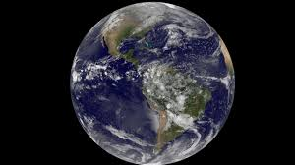  In this unit, pupils explore their local area and school grounds, learning to identify familiar features using aerial photographs and simple maps. They develop an understanding of human and physical features, use geographical vocabulary and directional language, and follow simple routes around the school and local environment.  Through fieldwork and observations, children learn to read and create simple maps, recognise local landmarks, record features of their surroundings, and suggest ways to improve their local environment. The unit introduces key geographical skills while helping pupils develop a greater understanding of the place where they live. |  | How am I making history?  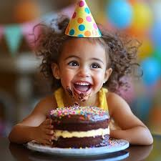  In this unit, pupils explore their own lives and experiences to understand that they are part of history. Using photographs, memories, family stories and significant events, they learn about the concepts of past, present and future and begin to understand how things change over time.  Children develop their chronological and historical enquiry skills by sequencing events on simple timelines, asking questions about the past, and using evidence from photographs and memories. They also compare what has changed and what has stayed the same in their own lives and those of their families, helping them recognise how their own experiences contribute to history. |  |  | What is the weather like in the UK?  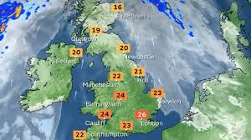  In this unit, pupils learn about the four countries of the United Kingdom, their capital cities and some major cities. They use simple maps and atlases to locate places in the UK and begin to develop their understanding of the country's geography.  Children also explore how weather changes across the seasons, observing and recording different weather patterns throughout the year. They learn to describe different types of weather, collect simple weather data, and understand how weather can affect everyday life. Through these activities, pupils develop their geographical knowledge, map skills and observational skills. |  |  | How have toys changed?  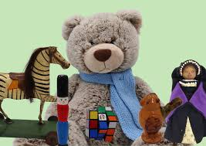  In this unit, pupils investigate how toys have changed over time by comparing toys from the past with those used today. Using photographs, artefacts and memories, they learn about childhood in different periods and begin to understand how historians use evidence to find out about the past.  Children develop their understanding of chronology by sequencing toys from different time periods and using historical vocabulary such as past, present, similar, different and change. They explore how toys, including teddy bears, have evolved over time and identify similarities and differences between children's lives then and now. |  |  | What is it like to live in Shanghai?    In this unit, pupils explore China and the city of Shanghai, developing their understanding of places beyond the UK. They use world maps, atlases and aerial photographs to locate China, name the continents and oceans, and investigate the human and physical features of Shanghai. Children compare life in Shanghai with their own local area, identifying similarities and differences between the two places.  Through map work and geographical enquiry, pupils learn to identify features such as rivers, roads and skyscrapers, use simple maps, and gather information about different locations. The unit helps children develop their knowledge of the wider world while building key geographical skills and understanding of place. |  |  | How have explorers changed the world?  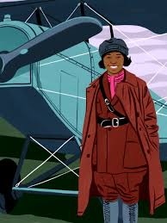  In this unit, pupils learn about significant explorers and their achievements, including figures such as Christopher Columbus and Matthew Henson. They explore why people travelled to new places, where explorers went, and how exploration has changed over time. Children use photographs, maps and other historical sources to find out about explorers and their journeys.  Pupils develop their understanding of chronology by placing explorers and key events on simple timelines and comparing exploration in the past with exploration today. They learn why some explorers are remembered and how their discoveries helped to increase our understanding of the world.
DT/Art | DT – Structures  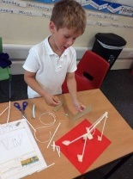  In this unit, children will focus on free-standing structures by designing and creating their own trim trail. They will investigate existing trim trails and other structures, discussing what makes them effective, appealing and safe. Using drawings, models and discussions, children will develop and communicate their ideas before selecting suitable materials and construction techniques to build their designs.  As they make and test their trim trails, children will learn how structures can be strengthened, stiffened and stabilised. They will use a range of tools and materials to construct their products and evaluate both existing designs and their own work against agreed design criteria, making improvements where needed. |  | Art – Drawing  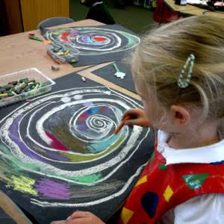  Drawing, sketchbooks (Spirals – Molly Haslund)  Focus: drawing, sketch books  NC Links  to use a range of materials creatively to design and make products  to use drawing, develop and share their ideas, experiences and imagination  to develop a wide range of art and design techniques in using colour, pattern, texture, line, shape, form and space  about the work of a range of artists, craft makers and designers, describing the differences and similarities between different practices and disciplines, and making links to their own work. |  |  | Art – Print  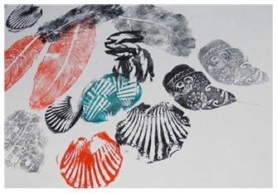  Print, colour, collage (Simple print making/ explore water colour/inspired by flora/fauna)  Focus: print, paint, collage, drawing, sketchbook  Surface and colour  NC Links  to use a range of materials creatively to design and make products  to use painting to develop and share their ideas, experiences and imagination  Then as autumn 1 |  |  | DT – Food  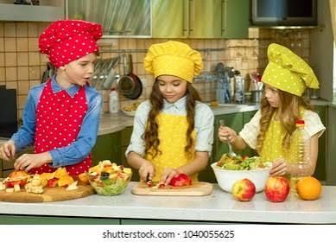  This KS1 Design and Technology unit on preparing fruit and vegetables helps children develop an understanding of cooking and nutrition. Pupils will learn where food comes from and explore the importance of a healthy, balanced diet. They will design and make simple food products using fruit and vegetables, selecting appropriate tools and ingredients while learning basic food preparation and hygiene skills. Children will evaluate existing food products and their own creations against design criteria, considering taste, appearance and suitability for the intended user. |  |  | Art – Three dimension sculpture  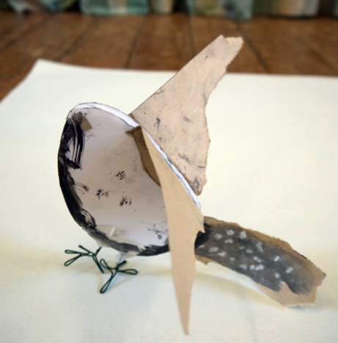  Focus: Working in three dimensions - sculpture (making birds)  Focus: sculpture, drawing, collage  NC Links  to use a range of materials creatively to design and make products  to use sculpture to develop and share their ideas, experiences and imagination  then as autumn 1 |  |  | DT – Mechanisms  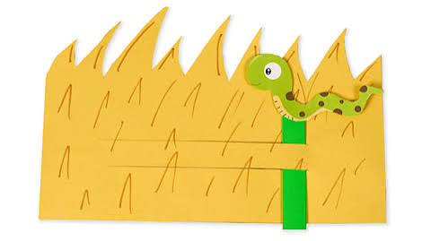  This KS1 Design and Technology unit on sliders and levers introduces children to simple mechanisms and how they can create movement in products. Pupils will explore and evaluate existing products that use sliders and levers, such as moving pictures and story books, before designing and making their own purposeful product for a chosen user. They will develop and communicate ideas through drawing and modelling, select appropriate materials and tools, and learn how mechanisms work to produce different effects. Children will then evaluate their finished products against design criteria, considering how successfully the mechanism works and how well it meets the needs of the user.
Science | Animals including Humans  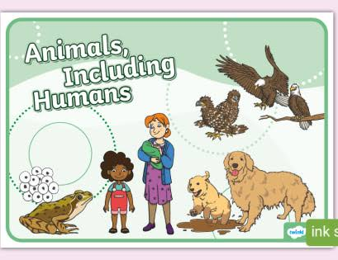  In Year 1, pupils learn about animals, including humans, by identifying and naming a variety of common animals, such as fish, amphibians, reptiles, birds and mammals. They learn to classify animals as carnivores, herbivores or omnivores, compare their physical features, and identify, draw and label the basic parts of the human body, linking these to the five senses. They also develop their scientific knowledge through observing, comparing and grouping living things.  Throughout the year, pupils revisit seasonal changes, observing how the weather and environment change across the four seasons and how day length varies. Working scientifically, children ask simple questions, make observations using simple equipment, carry out investigations, identify and classify objects, record data, and use their observations to answer questions and draw simple conclusions. |  |  |  |  | BSW weather:    In this unit, pupils explore the difference between weather and climate, building on their learning about seasonal changes. They learn how some greenhouse gases are produced, investigate the causes and effects of climate change, and discuss ways people can help to reduce its impact on the planet. Through practical enquiries, children develop their scientific skills by asking simple questions, making observations, identifying and classifying, carrying out simple tests, recording data, and using evidence to answer questions and draw conclusions. |  |  | Materials  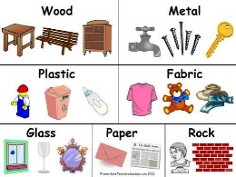  In this unit, pupils learn to identify and name a range of everyday materials, including wood, plastic, glass, metal, water and rock. They explore the difference between an object and the material it is made from, describe the simple properties of materials, and compare and group materials based on these properties.  Children also develop their working scientifically skills by asking simple questions, making close observations, carrying out simple tests, identifying and classifying materials, recording data, and using their observations to answer questions and draw conclusions. Seasonal changes are revisited throughout the year to strengthen understanding of the world around them. |  |  |  |  |  | Plants  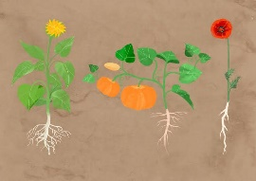  In this unit, pupils learn to identify and name a variety of common wild and garden plants, including deciduous and evergreen trees. They explore and describe the basic structure of flowering plants and trees, learning the names and functions of different plant parts.  Children also develop their working scientifically skills by asking simple questions, observing closely, identifying and classifying plants, carrying out simple investigations, recording data, and using their observations to answer questions. Seasonal changes are revisited throughout the year to help pupils understand how plants change across the seasons.
Computing | Introduction to Purple Mash (3 lessons)  Overview  This unit introduces Purple Mash to children and the essential basic knowledge and skills required for the Year 1 units. Through a range of activities, children will learn about 2Dos, saving work and navigating to key areas.  Key Learning:  To login and create my own avatar on Purple Mash. To open an activity and then save the work to the 'My Work' area.  To understand how to complete work in the 2Dos area in Purple Mash. | Creative Computing (4 lessons)  Overview  This unit gives children the opportunity to develop their mouse, keyboard and basic computing skills using creative tools. Children will use the 2DIY tools to paint, create jigsaws and make simple drag and drop games.  Key Learning To use paint tools to draw a picture.  To create a jigsaw using a digital device and share it so that others can play.  To create a placing game in 2DIY.  To create images and use these to make a game. |  |  | Data Explorers (6 lessons)  Overview  This unit introduces children to using software tools to group and sort recognisable objects. Children will develop their understanding of how this relates to organising and interpreting data. By the end of the unit, children have the opportunity to collect simple data and present it in a pictogram. Key Learning  To think carefully about the steps of grouping items.  To group items using a computer.  To sort different items.  To understand that data is information that can be collected and used.  To understand that data can be shown using pictures.  To collect data and create a pictogram. |  |  | Creating and following instructions (3 lessons)  Overview  This unit forms the basis for understanding simple algorithms and algorithmic thinking. This is facilitated though unplugged activities before moving to sequencing activities on digital devices. This is a foundational unit, introducing the basis of logical thinking in preparation for coding.  Key Learning  To understand that an algorithm is a set of instructions.  To follow and create simple instructions on a device.  To sequence algorithms that require a correct order. |  | Animated Stories (6 lessons)  Overview  In this unit children create digital books using the 2Create a Story tool. They learn how to work with images, text and sound. Children also learn how to animate simple objects.  Key Learning  To understand some differences between traditional books and digital books.  To draw a character for a 2Create a Story digital book.  To understand the difference between backgrounds and other objects on the screen in 2Create a Story.  To add animation to objects in 2Create a Story.  To add text to a 2Create a Story file.  To add sounds to a 2Create a Story file. | Coding (6 lessons)  Overview  This unit introduces children to coding using the block coding tool, 2Code. Children will explore simple instructions and relate this to code blocks. By the end of this unit, children will be able to make a simple program.  Key Learning  To understand that computer programs work by following instructions called code.  To use object and action code blocks to make a computer program.  To understand what an event is in coding.  To understand the purpose of an output and to be able to ‘read’ code to find out what it does.  To change aspects of the design view.  To plan and make a computer program. |  |  | Technology around us (4 lessons)  Overview  The focus in this unit is defining and understanding what technology is. Children will relate this to school, home, outside and to its use in the wider world.  Key Learning  To know what the word technology means.  To know what technology is used in school.  To consider the purposes of technology used in the wider world.  To understand the safe use of technology devices. |  |  | Making Beats (4 lessons)  Overview  This unit introduces digital music. Children will use the tools 2Explore and 2Beat to make their own digital music.  Key Learning  To compare music made using computers and music played by real instruments.  To explore mixing the sounds of different instruments using the 2Beat tool.  To compose a tune to match a picture of a scene.  To compose a beat to match a picture of a scene.
PSHE | My Healthy self: How can we look after our emotions?  Recognising and naming a range of emotions, pupils learn to identify facial and body clues linked to feelings. They explore what helps them feel calm and happy, understand the importance of rest and enjoyable activities, and practise simple strategies for managing different emotions. |  |  | Connecting with others: How can I help myself and others feel happy and safe?  Identifying what makes them and others special, pupils learn how friends, family and classmates can help and support each other. They explore how respect is shown through behaviour in different situations and identify simple strategies for managing disagreements in families and friendships. |  |  | The online world: How do we spend time online?  Understanding how to stay safe and respectful online and recognising the different ways people use the internet in everyday life. Pupils compare online and offline activities, explore appropriate online behaviour and identify strategies for staying safe and responding to unsuitable content. |  |  | Citizenship: How can I help others and the environment?  Learning how people can care for others and the environment through exploring the needs of babies, young children and pets, alongside ways to improve their school and local area. Pupils investigate how rules help communities stay safe, happy and fair, and consider how they can make a positive contribution to the world around them. |  |  | Health protection: How can I protect myself and others in daily life?  Exploring illnesses and injuries, understanding the roles of different healthcare workers in prevention and treatment and practising how to get medical help. Pupils investigate how germs spread, practise ways to reduce the risk of illness and learn when and how to seek help in an emergency. |  |  | Staying safe: How can I stay safe?  Recognising how rules help to keep people safe by identifying everyday hazards and understanding situations that could cause harm. Pupils explore ways to stay safe around roads and potentially dangerous items, recognise body clues that signal a problem and learn how to seek help from a trusted adult when needed.
RE | Christianity – Why do Christians call God ‘creator’?  focuses on helping pupils understand the Christian belief that God created the world, exploring creation stories and encouraging children to reflect on why creation is important to Christians. |  | Christianity – What is the ‘Nativity’ and why is it important to Christians?  focuses on helping pupils understand the story of Jesus’ birth and why Christians believe the Nativity is an important part of celebrating Christmas and God’s gift to the world. |  |  | Judaism – Why do Jewish families celebrate the gift of Shabbat?  focuses on helping pupils understand the importance of Shabbat in Jewish life, exploring how families celebrate this special day of rest, reflection and togetherness. |  |  | Christianity – What do Christians learn from stories of Jesus?  focuses on helping pupils explore stories told by and about Jesus, understanding the messages they teach and how Christians use these stories to guide their beliefs and actions. |  |  | Islam – What is important for Muslim families?  focuses on helping pupils understand the beliefs, values and practices that are important to Muslim families, including prayer, worship, belonging and caring for others. |  |  | Why should we look after the world?  focuses on helping pupils explore why people of different faiths and beliefs value and care for the world, encouraging respect, responsibility and stewardship of the environment.
PE | Ball Skills focuses on developing pupils’ ability to roll, throw, catch, bounce and control a ball, while improving coordination, accuracy and confidence in movement.  Dance focuses on developing pupils’ ability to move creatively, copy and perform simple movement patterns, respond to music and express ideas through movement, while improving coordination, balance and confidence. |  | Fundamentals focuses on developing core movement skills, including running, jumping, balancing, hopping and changing direction, while improving coordination, agility and body control.  Sending and Receiving focuses on developing pupils’ ability to accurately send and receive a ball using rolling, throwing, catching and tracking skills, while improving coordination, control and communication. |  |  | Invasion Games focuses on developing pupils’ ability to move into space, send and receive a ball, and work as part of a team, while improving decision-making, coordination and basic game skills.  Gymnastics focuses on developing pupils’ balance, coordination and body control through travelling, jumping, rolling and creating simple sequences of movement. |  |  | Net and Wall Games focuses on developing pupils’ ability to send and receive a ball or object, track its movement and control it with increasing accuracy, while improving coordination and reaction skills.  Fitness focuses on developing pupils’ speed, agility, balance, coordination and stamina through a range of fun physical activities that promote an active and healthy lifestyle. |  |  | Athletics focuses on developing pupils’ running, jumping and throwing skills, while improving speed, balance, coordination and overall physical confidence.  Target Games focuses on developing pupils’ ability to aim and send an object towards a target with accuracy and control, while improving concentration, coordination and decision-making. |  |  | Striking and Fielding focuses on developing pupils’ ability to strike a ball, track its movement and work cooperatively with others, while improving coordination, accuracy and basic game skills.  Team Building focuses on developing pupils’ communication, cooperation and problem-solving skills through collaborative challenges, while encouraging teamwork, confidence and resilience.
Music | Hey You! (Hip Hop)  How pulse, pitch and rhythm work together  - To know that music has a steady pulse, like a heartbeat.  - To recognise and name 2 or more instruments (male voice, bass guitar, drums, decks).  - To know that we can create rhythms from words, our names, favourite food, colours and animals.  - To begin to create their own rhythms.  - To accurately play a tuned instrument using notes C (G).  - To compose simple rhythms using notes C + D (E).  - To explore the use of pulse, pitch and rhythm. |  |  |  |  | In the Groove (different styles)  How to be in the groove with different styles of music  - To identify the pulse within the music they are listening to.  - To identify 5 different musical styles (Blues, Baroque, Latin, Irish Folk, Funk) and name some of them.  - To dance or move to the pulse of the music.  - To copy back rhythms they hear from their name, favourite food, colours, animals.  - To sing together in time, in all different styles.  - To accurately play a tuned instrument using notes C (D).  To compose a simple melody using simple rhythms using notes C + D (E). |  |  |  |  |  | Round and Round (Bossa Nova)  Pulse, rhythm and pitch in different styles of music  - To identify and find the pulse in a variety of songs.  - To recognise and name 2 more instruments (Singers, keyboard, bass, guitar, percussion, trumpets and saxophones).  - To copy back and clap rhythms back that they hear.  - To sing a song together with the actions.  - To play a tuned instrument accurately and in time using notes D, F, C + E.  To understand the use of pulse, rhythm and pitch in music.
French  Songs, games | greetings |  | Please/thankyou |  |  | Numbers to 10 |  |  |  |  |  | colours
Trips/Visitors | Animazing – animal workshop (visitor) |  | Beeches visit |  |  |  |  |  | Brickies workshop  History of Toys workshop – enquiry sent |  |  |  |  |  | cutty sark National Maritime museum Greenwich?  coach
Opportunities for outdoor learning and maximising locality | - Geography - mapping school grounds – walking around the school finding different human and physical features |  | - Science – school wildlife walk  - Science – seasonal walk |  |  | - PSHE – share books with the children in nursery  - Science – seasonal walk |  |  | - Science – material hunt around the school  - PSHE – Litter picking around school or local area |  |  | - Science – seasonal walk  - Maths /Computing – positions, turns and instructions |  |  | - Guided reading – litter pick (Clean Up)  - Science – recognising plants around the school and planting
How does the school’s theologically rooted Christian vision enable pupils, adults and children to flourish? | - Class rules and expectations  - Harvest |  | - Nativity production  - Christingle Service  - Christmas songs at The Beeches |  |  |  |  |  | - Community – PSHE – litter picking/ another beeches visit?  - Collective worship |  |  | - Family and Friends - PSHE |  |  | - Sports Day

