Year 5 + 6 – Reading Spine
Term | Autumn 1 | Autumn 2 | Spring 1 | Spring 2 |  | Summer 1 | Summer 2
Geog/  History | Greeks | Water, Weather, Climate | Local history (Hampton Court and Tudors) | Rivers |  | Leisure and entertainment in the 20th century
Guided reading | The Odyssey  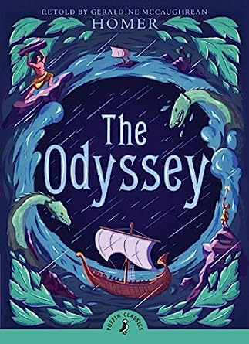 |  | The Nowhere Emporium  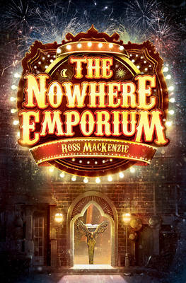 |  |  | Holes  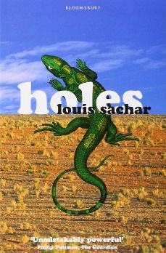
Literacy | *Poetry- mythical creatures  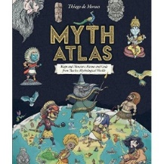  *Greek myths  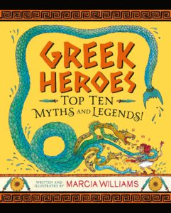 | *Non-chron report  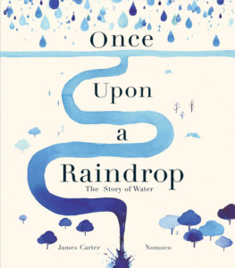  *Narrative | *Newspaper report- Tudor link  *Non-chron report- Tudors  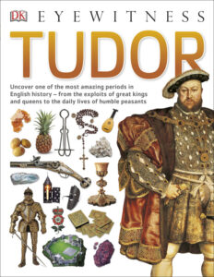 | *Narrative- Nowhere Emporium  Explanation- Magical machine  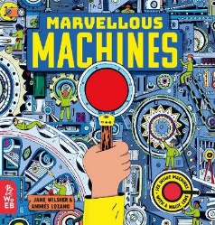 |  | *Balanced argument- choice of big questions  *Adventure story- Tom Sawyer | *Poetry -  Rollercoasters  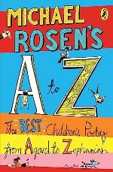  *Instructions – design own game and write instructions
Science | Space | Living things and habitats | Animals including humans |  | Properties of materials | Forces
Story time texts

Key authors | Malorie Blackman  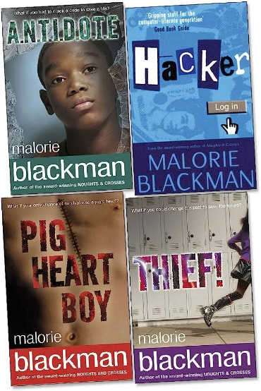 |  | Phillip Pullman  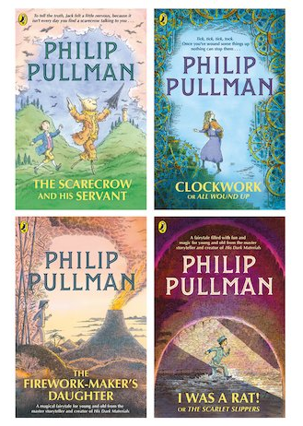 |  |  | Eva Ibbotson  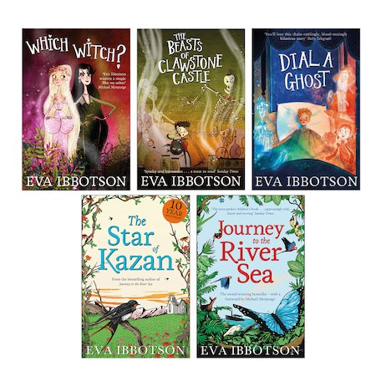
Old + Gold | 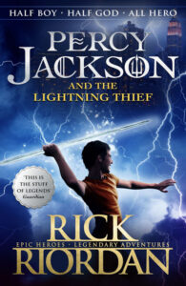 | 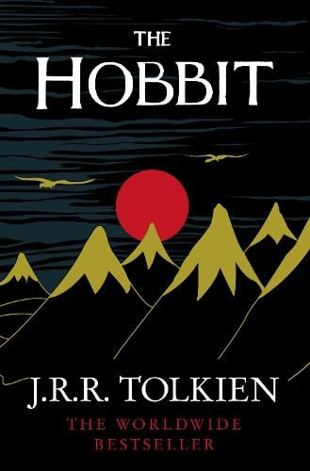 | 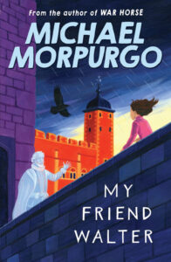 | 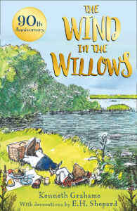 |  | 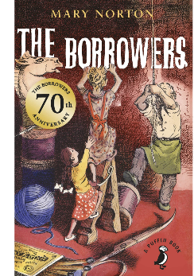 | 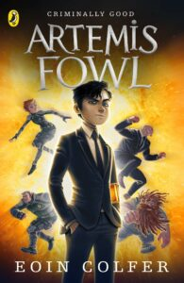
New + Bold | 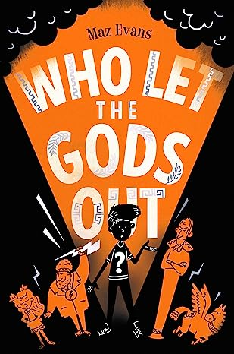  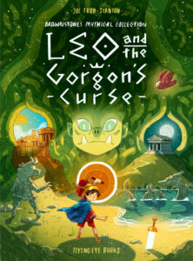  Graphic novel | 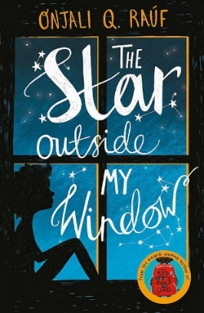 | 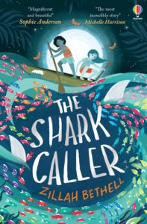 | 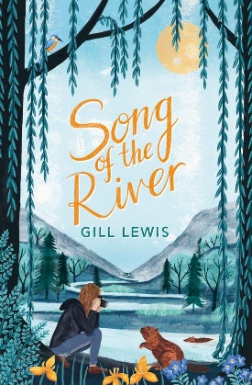  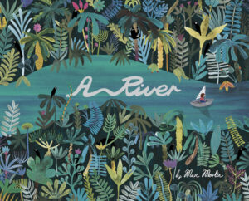  Picture books |  | 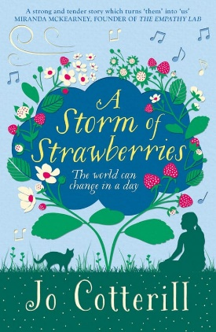 | 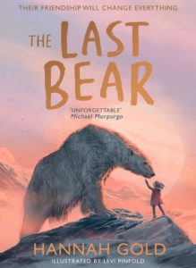  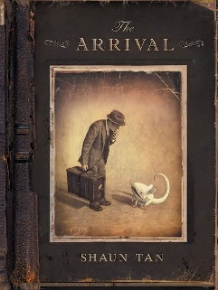  Picture books

