Year 3 + 4 – Reading Spine
Term | Autumn 1 | Autumn 2 | Spring 1 | Spring 2 | Summer 1 | Summer 2
Geog/  History | Stone Age | Antarctica | Romans and Celts | Volcanoes | Are all the settlements the same? | Ancient Egyptians
Guided reading | Wild Way Home  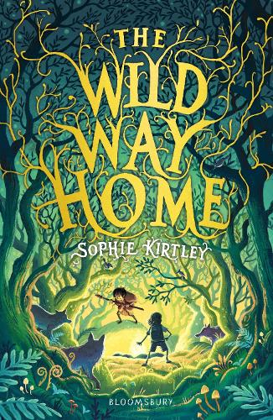 |  | Delta and the Lost City  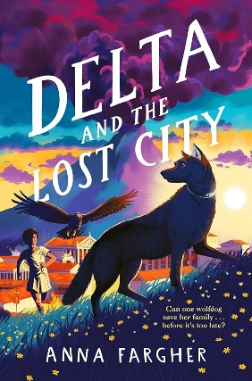 |  | Journey to the centre of the Earth  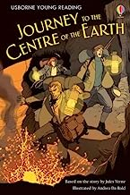
Literacy | Poetry – shape poems plants  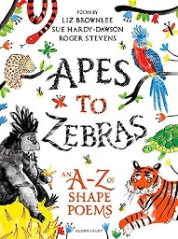  Instructions (how to wash a woolly mammoth)  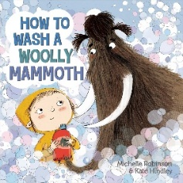  *Letters/Diaries –  character from guided reading text | *Narrative- guided reading text  Diary entry  Shackleton’s journey  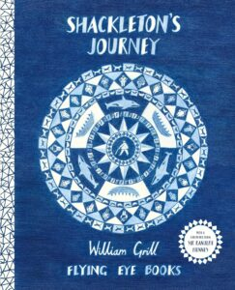 | *Persuasive letter linked to animal welfare  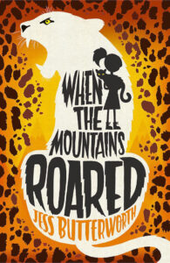  *Recount from trip/ immersion day | *Narrative- guided reading text  Poetry figurative language– animals  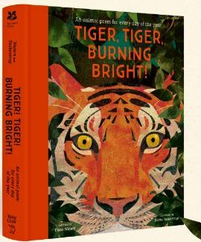 | *Instructions linked to science experiments  *Narrative- write an alternative fairytale (change an element of a fairytale/ different character’s perspective)  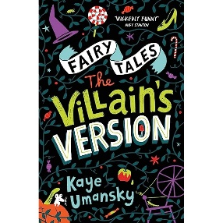  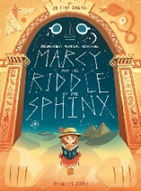 | - Newspaper reports linked to volcanoes topic  - Explanations – volcanoes  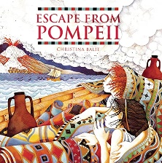  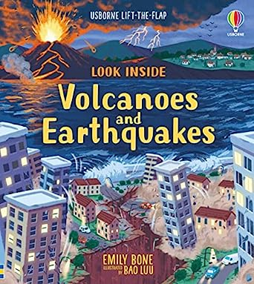
Science | Plants | Light | Animals including humans |  | Forces and Magnets | Rocks
Story time texts

Key authors | Dick King Smith  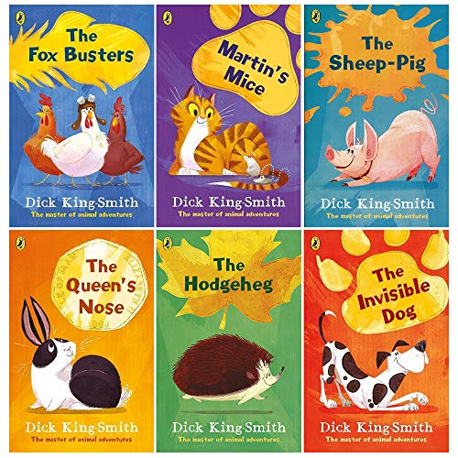 |  | Enid Blyton  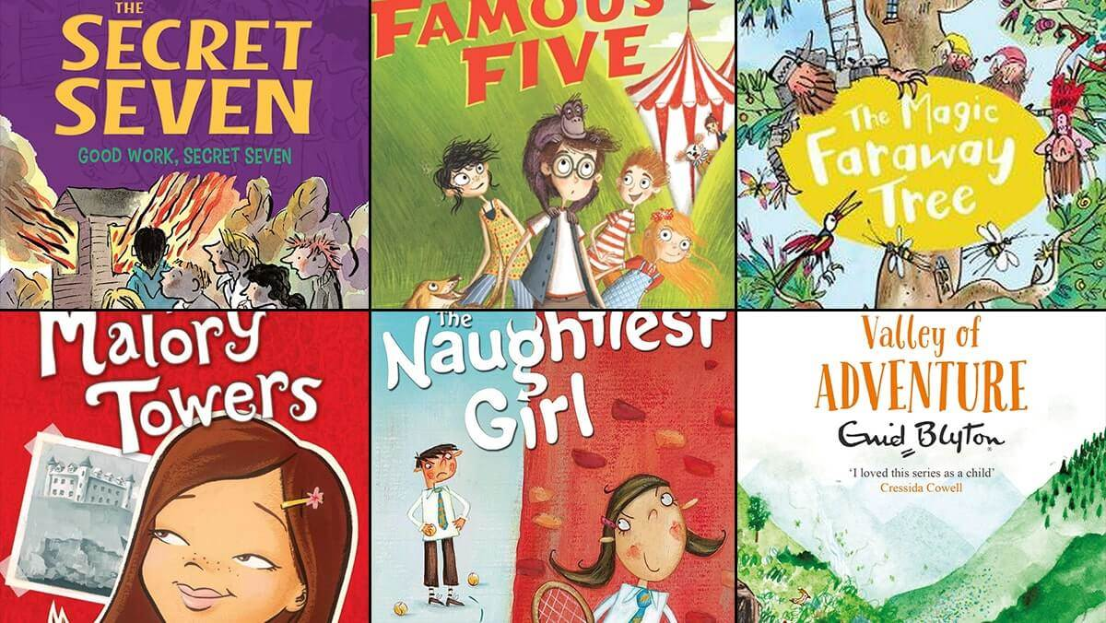 |  | Michael Morpurgo  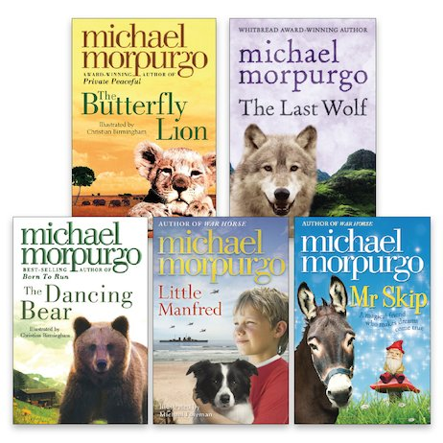
Old + Gold | 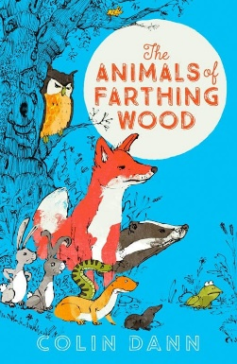  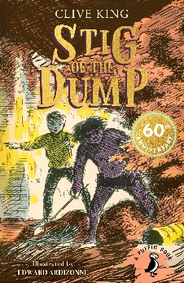 | 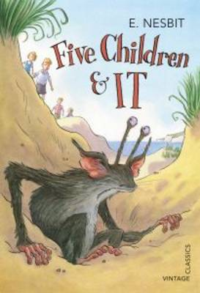 | 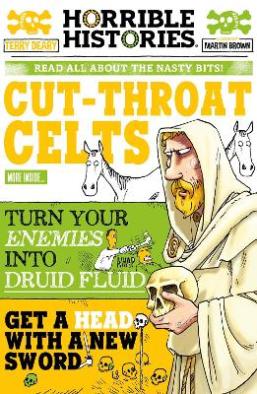 | 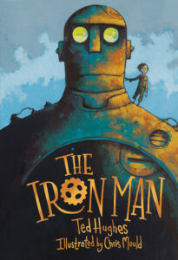 | 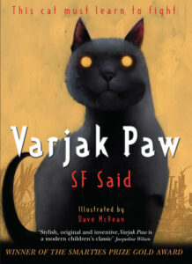 | 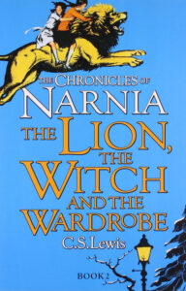
New + Bold | 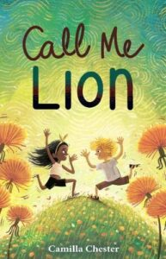  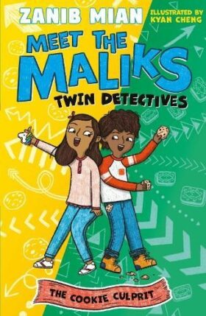 | 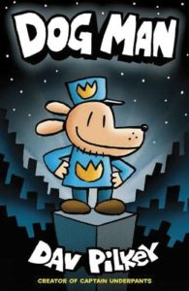  *Graphic novel  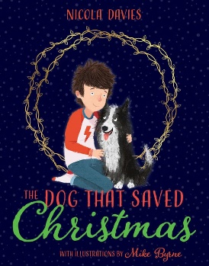  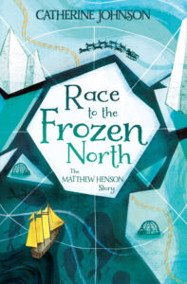 | 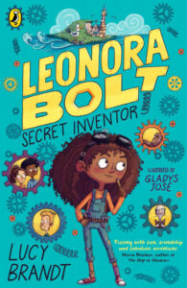  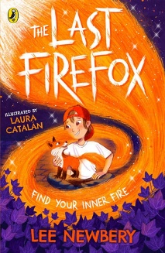  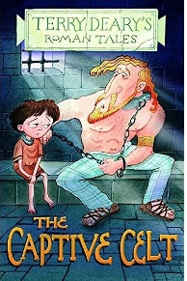 | 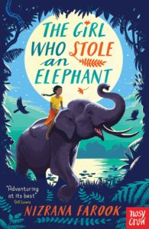  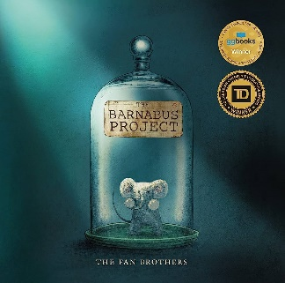  *Picture book | 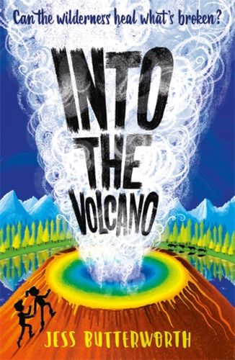  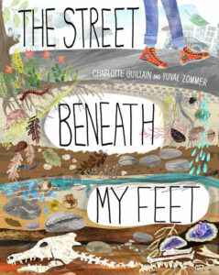 | 

