Pace – I read at the correct rate. Not too quickly, and not too slowly. My reading sounds right and makes sense.
1 | 2 | 3 | 4
I read really slowly and have to figure out each word on the page. I read so slowly that it really does not make sense.  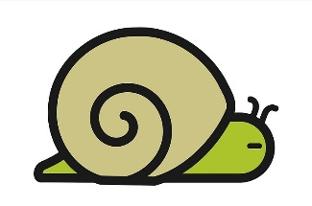 | I can be slow because I have to read word-by-word when I don’t know the words. I take breaks, pause too much and repeat words when I read.  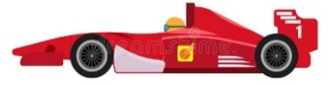  Or, I read so quickly that it makes it really hard to understand.  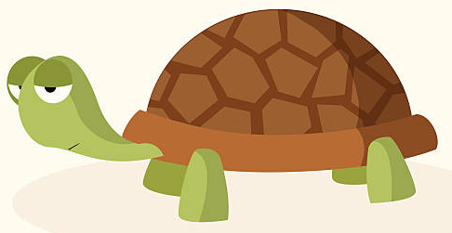 | I try to read like I talk Sometimes I go too fast or too slow. I might slow down when I am trying to figure out a tricky word.  I mostly read like I t-a-l-k but slow down on tricky words.  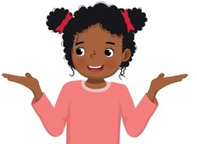 | I read like I talk. I only slow down, speed up or pause when it makes sense and sounds right.  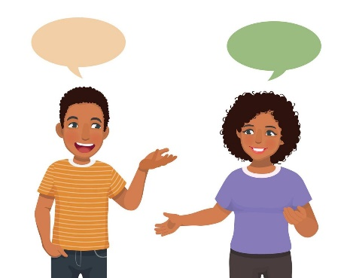

Accuracy – I read words correctly and in the correct order
1 | 2 | 3 | 4
I make mistakes when decoding words or read them in the wrong order. This makes my reading hard to understand.  He went the to park.  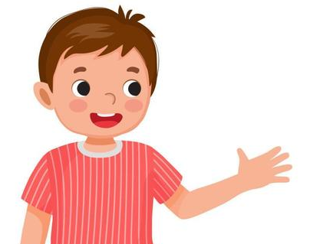 | I make mistakes decoding words or reading them in the right order but I try to self-correct.  He went the to - He went to the park. | I read almost all words accurately and am able to self-correct when I make a mistake.  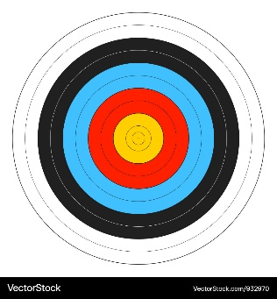 | I read words accurately and in the correct order.

Expression – I read with expression so that it sounds interesting and makes sense.
1 | 2 | 3 | 4
My reading sounds boring and doesn’t really make sense because I don’t read with expression. | I am trying to read with expression, but I may read it the wrong way sometimes. | I read with expression most of the time. My reading sounds interesting most of the time. | 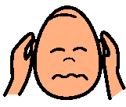  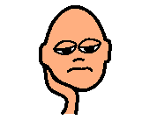    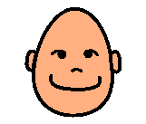  I always read with appropriate expression which sounds interesting and reflects the tone and meaning.

Punctuation – I use the punctuation to help me know how to read the story, so that it sounds right and makes sense.
1 | 2 | 3 | 4
I don’t pay attention to full stops, commas, exclamation marks, question marks and inverted commas.  I read word-by-word, or one word at a time, like a robot.  My reading doesn’t sound right or make sense.  I - like - to - read. - It - is - fun. | Sometimes I use the punctuation, but I might use it the wrong way.  Sometimes I read 2 or 3 words at a time. Sometimes I read word by word, like a robot.  I like - to - read. It - is fun. | I usually pay attention to punctuation, using it to show me where to pause or put emphasis.  Sometimes I still pause in the middle of a sentence or phrase or make a mistake.  I like to - read. It - is fun. | I always pay attention to punctuation. My reading sounds right and makes sense.  I like to read. It is fun!  I like to read. It is fun!

