What we are learning…
Reading: The Nowhere Emporium
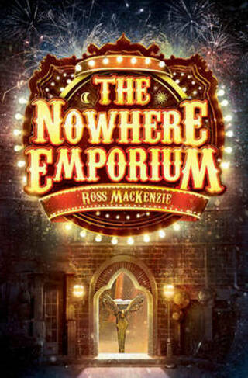
Writing: Newspaper report
Non-chronological report – The Tudors
Maths: Multiplication and division
Fractions
Decimals and percentages
Science: Properties of Materials
P.E.: Fitness, tag rugby
History: What was life like in Tudor England?
Art: Surface and colours
Music: Music and Words
French: A l’ecole
Computing: Spreadsheets
R.E. Islam – What helps Muslims to live a good life?
PSHE: Protecting the environment; compassion towards others

Trips / extra activities
Visit to Hampton Court
21st January
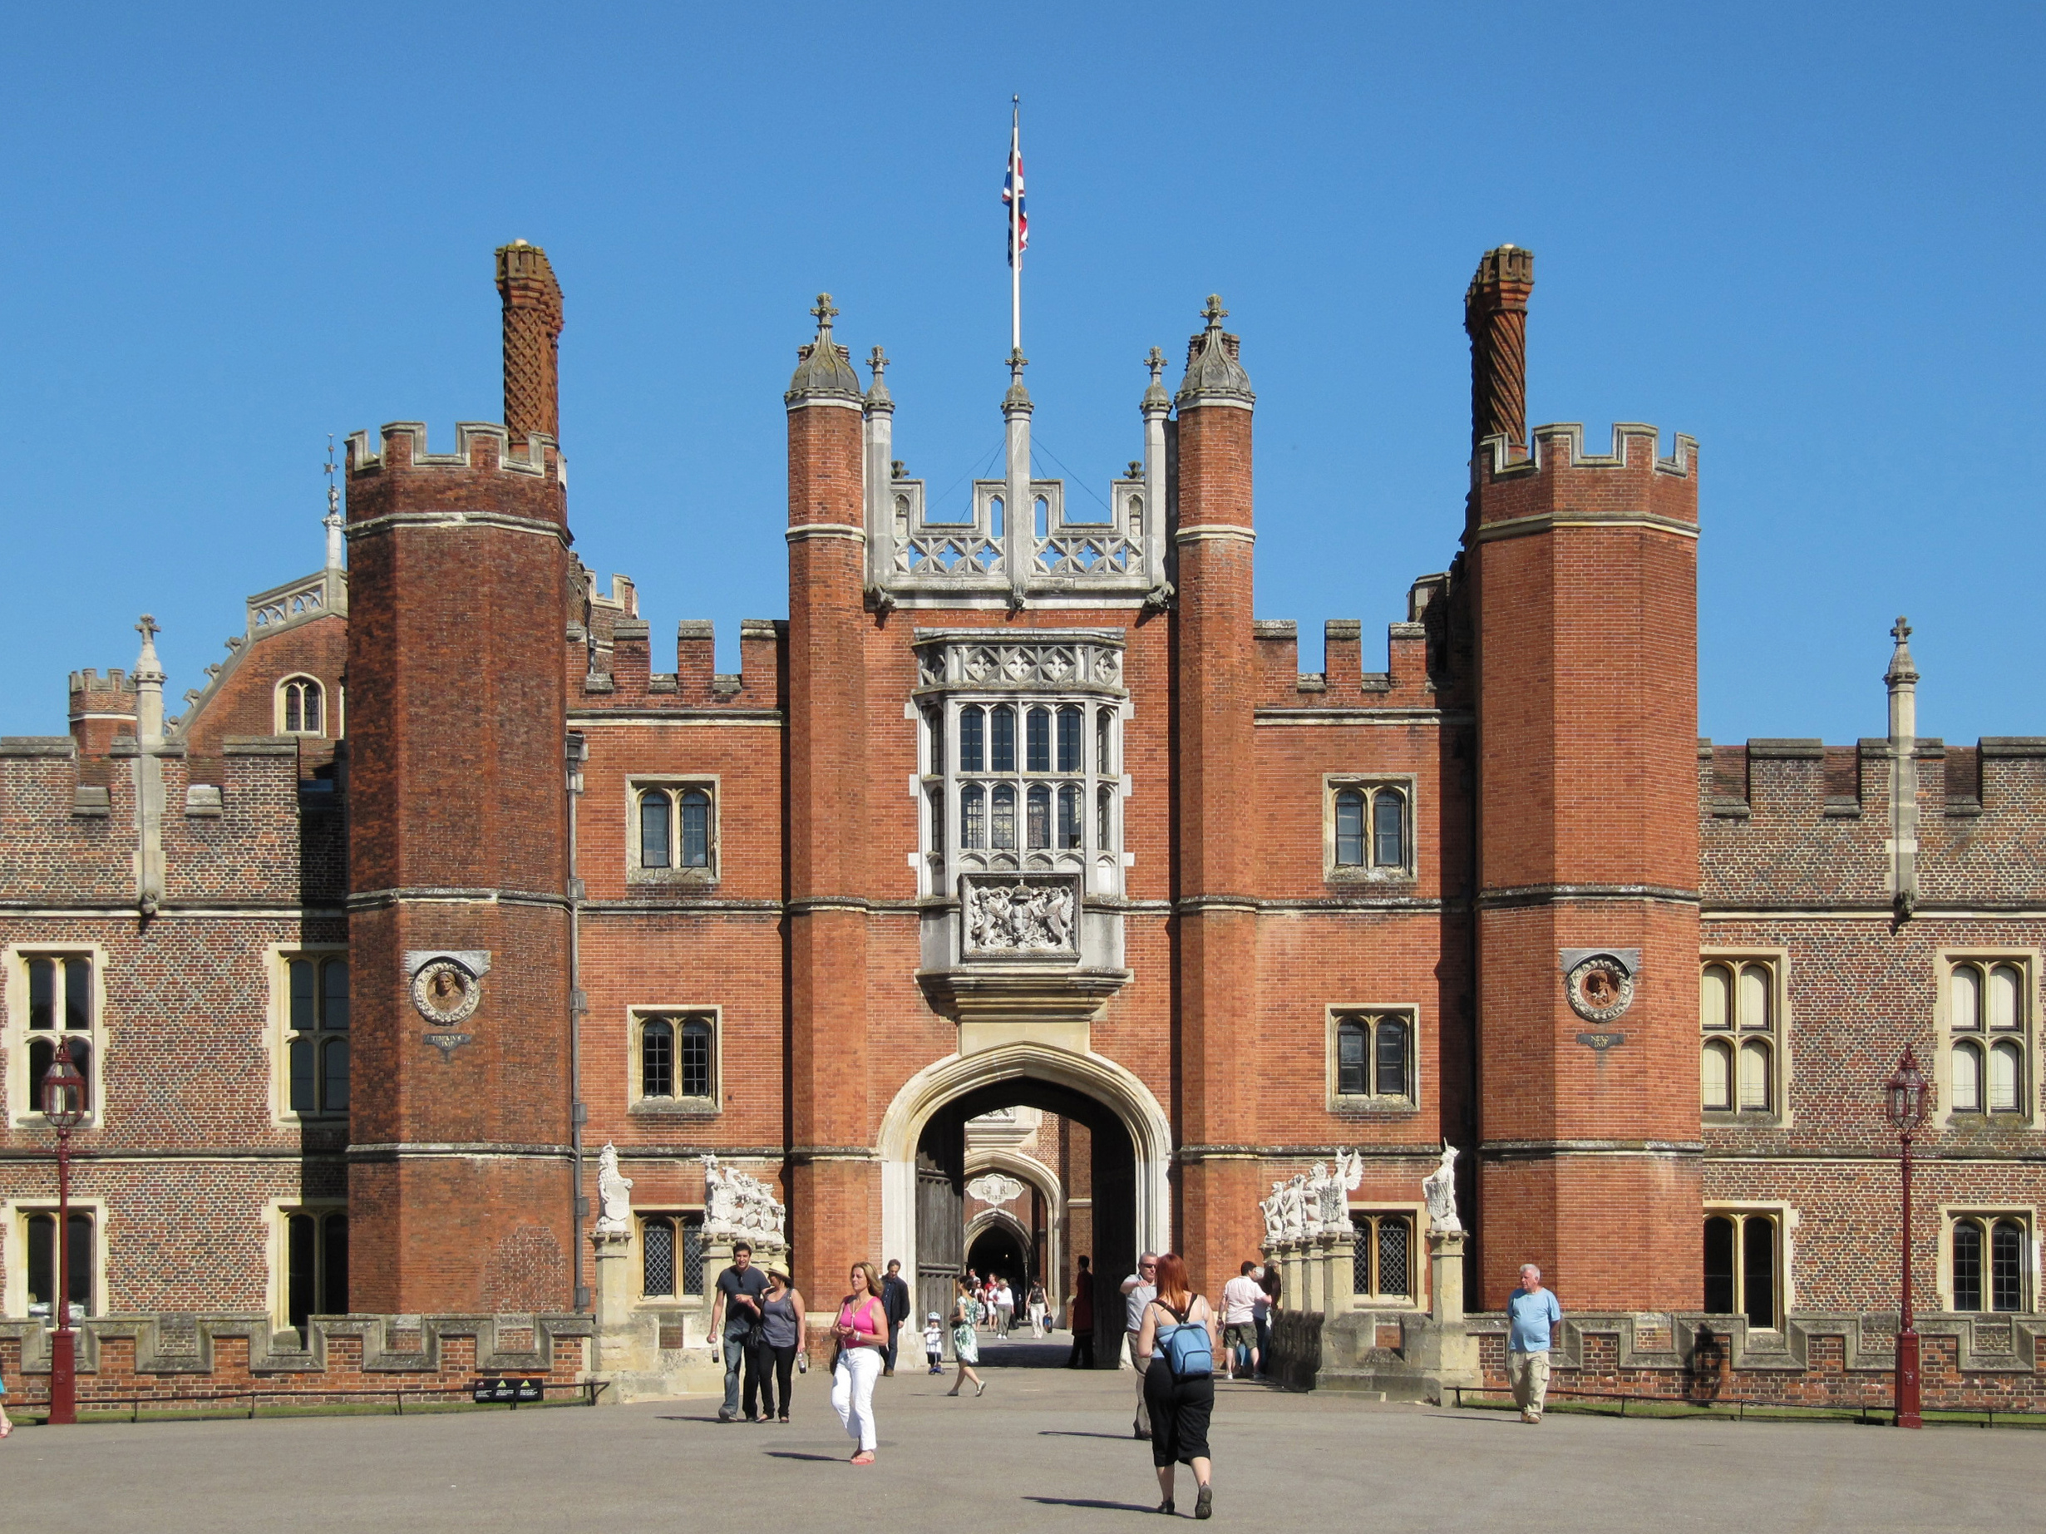

How can you help?

Reading – encourage reading a variety of texts e.g. ‘The Scarecrow and his Servant’ by Philip Pullman, ‘My Friend Walter’ by Michael Morpurgo, ‘The Shark Caller’ by Zillah Bethel

Visit the library – look for books about the Tudors, life cycles of animals and the environment
Times table Practise – all tables for quick recall
Encourage use of websites – maths.co.uk, spag.com, spelling shed.
History – Visit the Globe Theatre in London, read or watch a version of a Shakespeare play, go and see the Tudor paintings at the National Portrait Gallery
Useful websites –
https://www.bbc.co.uk/teach/class-clips-video/ks2-history-the-tudors-life-in-tudor-times-index/zdn7h4j
https://www.bbc.co.uk/bitesize/articles/z47cydm

Year 5
Spring Term 1
The Tudors
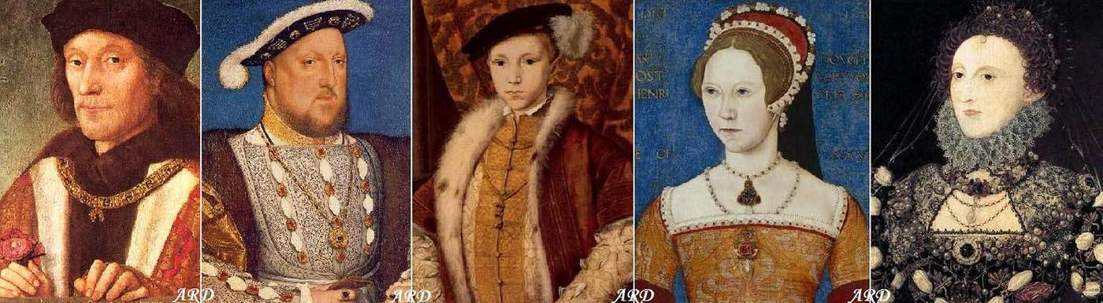

Key Vocabulary
Week 1 – reform & inherit
Week 2 – resist & perspective
Week 3 – futile & dismissive
Week 4 – influence & occupation
Week 5 – undoubtedly & inconvenience
Week 6 – diverse & pinnacle

Vision and values
“All things are possible for one who believes”
Protecting the environment – compassion towards others
Respect for all religions

