What we are learning…
Reading: Wild Way Home – Sophie Kirtley
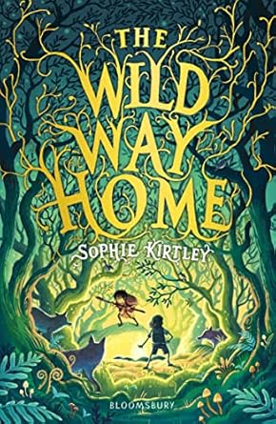

Writing: Instructions, a narrative based on our guided reading text and poetry
Maths: Place Value & Addition and Subtraction
Science: Animals including humans
P.E: Fundamental skills and dodgeball
History: The Stone Age, Bronze age and Iron Age
Art: Drawing – gestural with charcoal
Music: Rhythm patterns

French: Moi dans le monde
Computing: Coding
R.E: Sikhism – what do Sikhs value?
PSHE: Dental Hygiene and balanced lifestyles

How can you help?

Reading – encourage reading a variety of texts for example, The Wild Way Home by Sophie Kirtley, When the sky falls by Phil Earle, The last wild by Piers Torday, Stone Age boy by Satoshi Kitamura
Visit the library – look for books linked to the Stone Age, Skeletons, Stone Henge etc
Visit relevant museums – Natural History Museum,
Times table Practice – quick recall using ttrs – particularly studio and sound check
Encourage use of websites – maths.co.uk, spag.com, spelling shed.
History – Have discussions at home about the Anglo Saxons and their effect on Great Britain
Useful websites –
https://www.purplemash.com

Trips / extra activities
Natural History Museum Aut 2
Stone Age day

Year 3 and 4
Autumn Term 1
Stone Age, Bronze Age and Iron Age
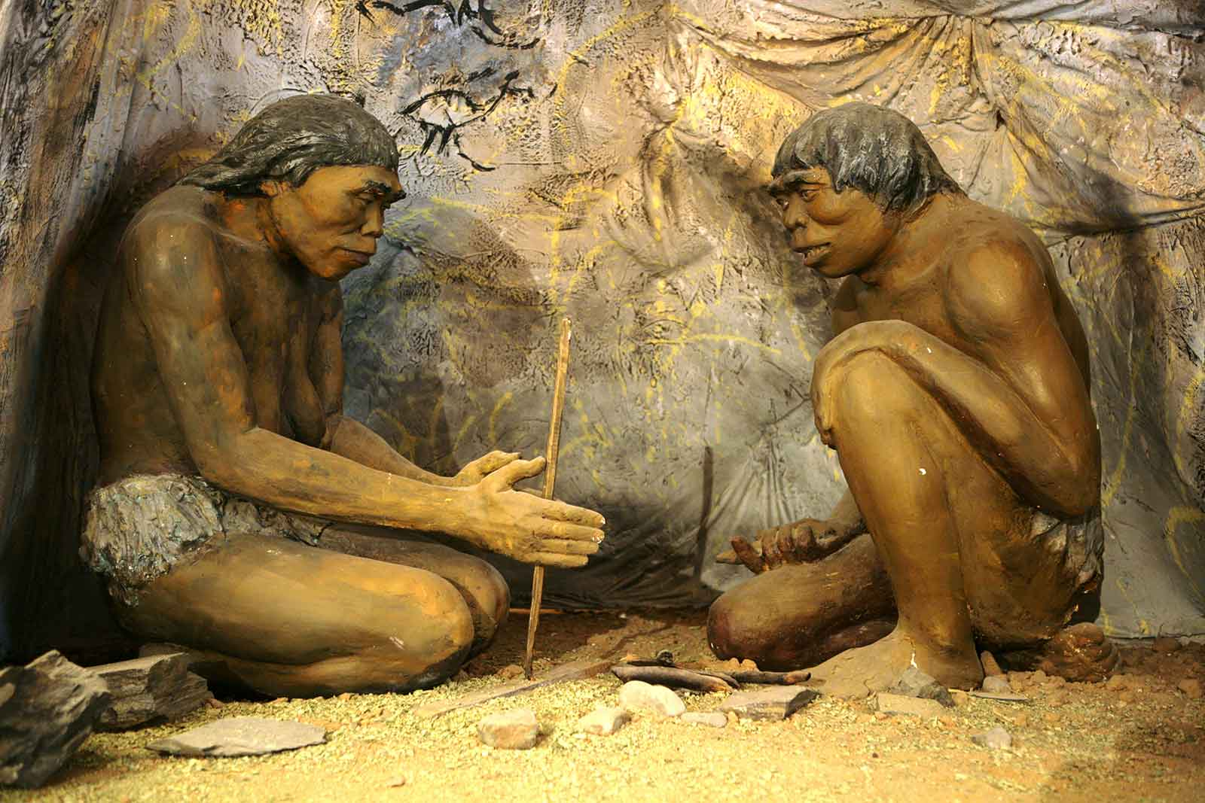

Key Vocabulary
Week 1 – Carve Gleaming
Week 2 – Tinge Shimmer
Week 3 – abandoned releasing
Week 4 – Captivity fragile
Week 5 – glimpse shattering
Week 6 – hilarious miniscule
Week 7 – Concentrate muffled

Vision and values
“All things are possible for one who believes”
Commitment & love- learning about the changes to British people and Britain during the Stone Age period

